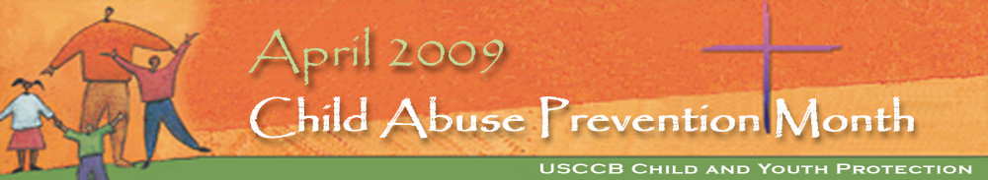

THE DIOCESE OF BRIDGEPORT

OFFICE OF SAFE ENVIRONMENTS PROMOTES AWARENESS

OF

CHILD ABUSE PREVENTION MONTH

APRIL

2009

(RESOURCES FOR PARISHES)

For additional parish resources in English and in Spanish, please visit www.usccb.org. Office of Child and Youth Protection or www.bridgeportdiocese.com

Additional articles and announcements will follow throughout the year in the Fairfield County Catholic and in upcoming Bridge Announcements

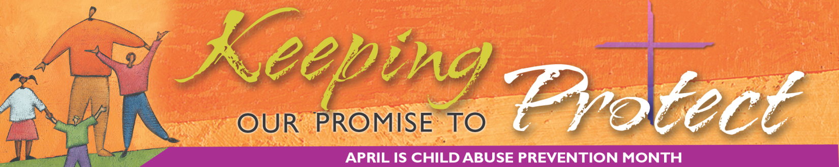
Suggested Bulletin Announcements
Four bulletin announcements for April
April is Child Abuse Prevention Month (April 5, 2009)
April is national Child Abuse Prevention Month. It is most appropriate that Child Abuse Prevention Month is held during the Easter season. There is no better time than Easter to celebrate the protection of our most valuable gift from God—our children. For information on how you can become more informed and involved in keeping our children safe by attending a local workshop on child safety and abuse prevention, please speak with our parish Safe Environment coordinator or call: Erin Neil, L.C.S.W. Director of Safe Environments & Victim Assistance Coordinator (203) 416-1406
Five Steps to Safer Environments (April 12, 2009)
All clergy, employees, volunteers and Independent Contractors in the Diocese of Bridgeport learn about child abuse prevention through the VIRTUS program and are required to complete a criminal background check through their school or parish office. VIRTUS training details five steps to prevent child sexual abuse: All parents and parishioners are welcome and encouraged to participate in this free child abuse awareness and prevention program.
- Know the early warning signs of an inappropriate relationship with a child and stop abuse before it happens! (VIRTUS teaches you to spot these warnings)
- Control access to children by ensuring a criminal background check is completed on every employee, volunteer and independent contractor in schools and parishes.
- Monitor all programs by ensuring that two or more trained and background checked adults are present at all times when minors are participating.
- Be aware of where you child spends their time, especially online!
- Communicate any early concern you have to your Pastor and the victim assistance coordinator Erin Neil (203) 416-1406/ Cell: 650-3265 or Bill Hoey (203) 241-0987. For a schedule of upcoming classes visit the website www.virtus.org. Select REGISTRATION and select BRIDGEPORT DIOCESE
April is Child Abuse Prevention Month -Be Vigilant (April 19, 2009)
It is vitally important that we are constantly vigilant—that we always observe the behaviors of those who interact with children and communicate our concerns to the appropriate parties. Sometimes this means communicating our safety concerns to our children. Parents must also listen carefully to their children and observe both their children’s activities and the behavior of older children and adults who interact with them. When children exhibit dramatic behavioral changes, adults must find out what caused the changes. Being aware of what’s happening with our children means talking to, listening to, and observing them—at every opportunity)
April is Child Abuse Prevention Month – Prevent abuse by making a call….(April 26, 2009)
Please do not let child abuse go un-reported, help is available! If you or someone you know has been a victim of abuse by any person from the Church, help is available. Child sexual abuse is never a child’s fault. Please contact one of our victim assistance coordinators Erin Neil (203) 650-3265 and Bill Hoey (203) 241-0987. If you have any reason to suspect that a child has been abused or could be in danger of abuse please do not wait, immediately contact one of our victim assistance coordinators and the State of CT Child abuse and neglect hotline 1-800-842-2288.

THE U.S.C.C.B. CHARTER FOR THE PROTECTION OF CHILDREN & YOUNG PEOPLE
In 2002 United States Conference of Catholic Bishops drafted a landmark document called the Charter for the Protection of Children and Young People (The Charter). The Charter contains a comprehensive set of standards and procedures to address sexual abuse of minors and includes guidelines for reconciliation, healing, accountability and the prevention of abuse through Safe Environment programs.
SAFE ENVIRONMENT PROGRAMS
Safe Environment offices are currently in place in U.S. Archdioceses and Dioceses to prevent child abuse, provide outreach and assistance to victims and to ensure timely reporting of suspected child abuse to civil authorities. Safe Environment programs include criminal background checks, Codes of Conduct, Sexual Misconduct policies, and educational programs for all clergy, employees, volunteers, children and youth to prevent child sexual abuse.
In the Diocese of Bridgeport we have a well established Safe Environment program with a full time director Erin Neil who is also a licensed clinical social worker. Ms. Neil oversees the Safe Environment programs and provides assistance to victims along with fellow Victim Assistance coordinator Bill Hoey L.C.S.W.
AWARENESS TRAINING: We have consistently used The VIRTUS Protecting God’s Children Program for adults and the Think First and Stay Safe Program for children. Safe Environment training teaches adults and children to identify the most common lures and tricks employed by a child molester to prevent abuse and how to make a report if abuse is ever suspected. We have a dedicated counselor from Catholic Charities Ms. Tara Mingione who delivers the Children’s Safe Environment program K-12 each year!! She meets with more than 10,000 students annually and provides a consistent message of child abuse prevention. Parents are always provided with a chance to meet with her and preview the program before training is delivered in the classroom. Our Catholic schools distribute informational material and parents guides to each family with a child enrolled in our schools in advance of the program so that training begins at home. We have had approximately 40 volunteer facilitators of the VIRTUS program over the past five years. Collectively training reached over 60,000 adults and children. We distributed an additional 40,000 informational brochures and parent guides to the public. In the State of CT, the Catholic Church trained a combined total of 200,000 people, distributed over 100,000 informational brochures. Together we conducted more 50,000 background checks!
LOCAL IMPLEMENTATION: Our Pastors, Directors of Religious Education, School Principals, Program Directors and Local Safe Environment coordinators have a big job when it comes to implementing Safe Environments. Every day they are charged with the task of ensuring that every adult working and volunteering in the parishes completes a criminal background check, reads and signs our polices and attends VIRTUS training. The Safe Environment coordinators work tirelessly to ensure all environments in our schools, parishes and programs are as safe as possible.
THE DIOCESE OF BRIDGEPORT OFFICE OF SAFE ENVIRONMENTS
STEPS FOR REPORTING AN INCIDENT OF ABUSE
Am I required to report a suspicion of sexual abuse, other abuse or a violation of the Code of Conduct?
The answer is YES! If you have actual knowledge of or have reasonable cause to suspect abuse or misconduct against a minor by a member of the Clergy, Seminarian, Lay Employee, Lay Volunteer or Independent Contractor of the Diocese of Bridgeport, please report that information immediately to:
Erin Neil, L.C.S.W., Director of Safe Environments & Victim Assistance Coordinator, (203) 650-3265
Or
Bill Hoey, L.C.S.W. Victim Assistance Coordinator, (203) 241-0987
AND
The CT Department of Children and Family (D.C.F.) Child Abuse and Neglect Hotline
Mandated Reporters are required by law to cause an oral report to be made directly to D.C.F. or to the Police within 12 hours of becoming aware of an incident or a concern.
1-800-842-2288
You must also notify your immediate supervisor. If the incident of suspected abuse involves a supervisor, contact Safe Environments directly.
WARNING SIGNS: If you have any concern about the safety of a child or if you have observed an early warning sign of inappropriate conduct or violation of the Diocese of Bridgeport Code of Conduct, you should report this information to Safe Environments immediately. When in doubt, REPORT!!! Call immediately with what you know. Your information will be handled with a high level of confidentiality at all times however full anonymity cannot be guaranteed in cases involving abuse of a minor.
Other Important Numbers:. For all questions relating to background checks, please call Louise Stewart Spagnuolo at (203) 416-1402
****PLEASE POST IN YOUR PARISH OR SCHOOL OFFICE

Suggested Prayer Petitions for General Intercessions
You may choose to use one or more of these during the month of April or any time throughout the year.
Intercessions
That the Church, its leaders, and its people may be signs of
hope and healing in a world broken by sin and division.
-We pray to the Lord.

That the bishops and priests of the Church will be good and
faithful shepherds, guiding their people with compassion and
integrity.
- We pray to the Lord.

That young men and women will listen to God’s call to service
in the priesthood and consecrated life and will strive to
conform their lives to Christ, who suffered that we might live.
-We pray to the Lord.

That civil leaders will work for laws that protect the most
vulnerable members of society from oppression and abuse.
-We pray to the Lord.

That families will grow stronger in their love for one
another so that children may be raised in safe and nurturing
environments.
- We pray to the Lord.

That children and young people who have been victims of
abuse may find healing and hope through the ministry of Christ
and his Church.
-We pray to the Lord.

CHILD ABUSE PREVENTION BLESSING

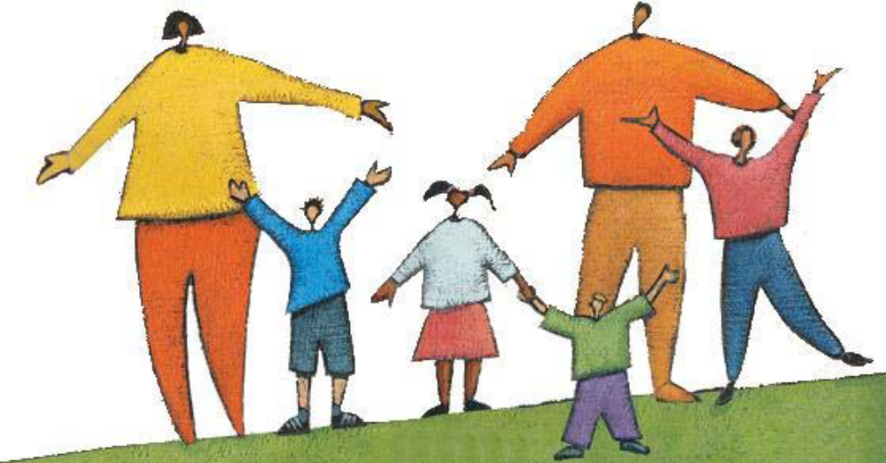

Dear Lord,
We ask You to bless these Your holy people who have participated in the Church’s efforts to help stop child sexual abuse. Open their hearts to Your call to be the “ears, eyes and voice of children and young people” everywhere. Give them the vision and grace needed to fulfill the special commitments that each of them has made to making their homes, churches, schools, communities and world a safer place for all
God’s Children. Amen

© Joan Vienna, Office of Safeguard the Children 10/8/08

ROSARY FOR
Healing AND Protection

Resource provided by the U.S.C.C.B.
Secretariat of Child and Youth Protection

ROSARY FOR
Healing AND Protection

The Secretariat of Child and Youth Protection seeks to ensure that all children are safe from sexual abuse and to provide assistance and support to victims on the path to healing.

You can help in these efforts through participation in safe environment training, by advocating for children and young people who may be at risk, and by offering these efforts for healing and protection to God in prayer.

This rosary will help you to lift up these needs in prayer, offering them to God through Mary who offers her loving protection to all her children.

HOW TO PRAY THE ROSARY

† Make the sign of the cross. Holding the crucifix, say the Apostles’ Creed.

† On the first bead, say an Our Father.

† Say one Hail Mary on each of the next three beads, one for Faith, one for Hope, and one for Charity. Say the Glory Be.

† Go to the main part of the rosary. For each of the five decades, announce the Mystery, and then say the Our Father. While fingering each of the ten beads of the decade, next say ten Hail Marys while meditating on the Mystery. Then say a Glory Be.
(After finishing each decade, some say the following prayer requested by the Blessed Virgin Mary at Fatima: “O my Jesus, forgive us our sins, save us from the fires of hell, lead all souls to heaven, especially those who have most need of your mercy.”)

† After saying the five decades, say the Salve Regina (Hail, Holy Queen), followed by this dialogue and prayer:

V. Pray for us, O holy Mother of God.

R. That we may be made worthy of the promises of Christ.

Let us pray. O God, whose only-begotten Son, by his life, death, and Resurrection, has purchased for us the rewards of eternal life, grant, we beseech you, that meditating on these mysteries of the most holy rosary of the Blessed Virgin Mary, we may imitate what they contain and obtain what they promise, through the same Christ our Lord. Amen.
PRAYERS OF THE ROSARY

The Apostles’ Creed

I believe in God the Father almighty,
Creator of heaven and earth.
And in Jesus Christ, his only Son, our Lord,
who was conceived by the Holy Spirit,
born of the Virgin Mary,
suffered under Pontius Pilate,
was crucified, died, and was buried.
He descended into hell;
the third day he rose again from the dead;
he ascended into heaven,
and sits at the right hand of God the Father almighty,
from thence he shall come to judge
the living and the dead.
I believe in the Holy Spirit,
the holy Catholic Church,
the communion of saints,
the forgiveness of sins,
the resurrection of the body
and life everlasting. Amen.
Our Father

Our Father who art in heaven,
hallowed be thy name;
thy Kingdom come,
thy will be done on earth as it is in heaven.
Give us this day our daily bread,
and forgive us our trespasses,
as we forgive those who trespass against us;
and lead us not into temptation,
but deliver us from evil.

The Hail Mary

Hail, Mary, full of grace,
the Lord is with thee.
Blessed art thou among women
and blessed is the fruit of thy womb, Jesus.
Holy Mary, Mother of God,
pray for us sinners,
now and at the hour of our death.
Amen.

Glory Be

Glory be to the Father
and to the Son
and to the Holy Spirit,
as it was in the beginning
is now, and ever shall be
world without end. Amen.
JOYFUL MYSTERIES
Said on Mondays and Saturdays

The Annunciation
Then the angel said to [Mary], "Do not be afraid.” (Lk 1:30)
The angel Gabriel greeted Mary with words to calm her fears. God wants everyone, especially the most vulnerable, to live in his peace, free from all fear and pain. It is our responsibility, as children of our loving God, to create an environment in which our children can grow up free from fear of those who might hurt or abuse them.

The Visitation
“My soul proclaims the greatness of the Lord.” (Lk 1:46)
After receiving the news that she would become the mother of God’s Son, Mary’s first action was one of compassion. She went to her kinswoman, Elizabeth, and offered aid and comfort. Following her example, we must reach out to those around us in need of hope and healing, offering our assistance and patience as they embrace God’s healing love.

The Nativity of the Lord
She gave birth to her firstborn son. She wrapped him in swaddling clothes and laid him in a manger, because there was no room for them in the inn. (Lk 2:7) Jesus, the Son of God, entered the world as a vulnerable child. He was not counted among the great and powerful, instead lying in a manger. We are called to protect all those who are vulnerable, especially children, by providing them with safe places to live and grow

The Presentation
“You yourself a sword will pierce so that the thoughts of many hearts may be revealed." (Lk 2:35)
The experience of child sexual abuse is shattering and can make a person feel as if his or her heart and world is torn asunder. We pray for those victims who are seeking healing and strength. Their path is challenging, but our loving support can make it easier.

Finding the Child Jesus in the Temple
His mother said to him, "Son, why have you done this to us? Your father and I have been looking for you with great anxiety." (Lk 2:48)
Child sexual abuse affects not only the victim, but his or her family as well. Our healing efforts must extend to these family members, to alleviate their pain and anxiety and help them to grow ever closer to God’s healing love.
The Transfiguration
[Jesus] was transfigured before them; his face shone like the sun and his clothes became white as light. (Mt 17:2)
In his Transfiguration, Peter, James, and John saw Jesus as he truly is in all his divine glory. So must we see victims of sexual abuse as they are – the precious children of God, worthy of dignity and respect. We must do all that we can to aid in their healing and to assure them of the love of God and his people.

Institution of the Eucharist
"This is my body, which will be given for you; do this in memory of me." …"This cup is the new covenant in my blood, which will be shed for you.” (Lk 22:19-20)
In the gift of the Eucharist, Jesus makes present his sacrifice of redeeming love. This sacrifice makes us whole as one Body of Christ. We pray that Jesus may heal all that wounds of his Body, most especially the wounds caused by the sexual abuse of children and young people.
LUMINOUS MYSTERIES
Said on Thursdays

Baptism by John
A voice came from the heavens, saying, "This is my beloved Son, with whom I am well pleased." (Mt 3:17)
Every child is beloved by God, precious in his sight. There is no room in the Church for those who would harm children, betraying their trust and destroying their innocence. All members of the Church must do their part to make the Church and society safe for children.

Wedding at Cana
Jesus said to her, "Woman, how does your concern affect me? My hour has not yet come." His mother said to the servers, "Do whatever he tells you." (Jn 2:4-5)
A guest at a wedding in Cana, Jesus’ mother stepped in to assist the couple in their time of need. We must follow her example by taking active steps to come to the aid of children who are at risk of abuse, to be vigilant in protecting them, and to advocate on behalf of those who become victims.

Preaching of the Kingdom and Call to Conversion
"This is the time of fulfillment. The kingdom of God is at hand. Repent, and believe in the gospel." (Mk 1:15)
Jesus boldly preached the coming of God’s kingdom, reminding his hearers of the need to conform their lives to God’s laws. As members of God’s Church, we must boldly remind all elements of society of the need to protect children and young people. The message may not be welcome, but it is essential.

SORROWFUL MYSTERIES

Said on Tuesdays and Fridays

Agony in the Garden
He was in such agony and he prayed so fervently that his sweat became like drops of blood falling on the ground. (Lk 22:44)
Many victims of child sexual abuse suffer in silence for years, wrestling alone with the agony of their memories and pain. We pray that the Church may always be a place where they can come to share their stories, be received in love and compassion, and be supported on the path to healing.

Scourging at the Pillar
Then Pilate took Jesus and had him scourged. (Jn 19:1)
The experience of child sexual abuse may leave scars no less profound than the scars of a scourging, though they often remain unseen. We must strive to make our parish communities places where victims can feel safe to share their burdens and to find healing and peace.

Crowning with Thorns
And the soldiers wove a crown out of thorns and placed it on his head, and clothed him in a purple cloak, and they came to him and said, "Hail, King of the Jews!" And they struck him repeatedly. (Jn 19:2-3)
GLORIOUS MYSTERIES
Said on Sundays and Wednesdays

The Resurrection
“Why do you seek the living one among the dead? He is not here, but he has been raised.” (Lk 24:5-6)
The Father’s gift of healing is a wondrous thing, bringing new life and hope from what was pain and despair. We pray for all victims of child sexual abuse, that they may come to abundant new life in the Risen Lord.

The Ascension into Heaven
As [the apostles] were looking on, [Jesus] was lifted up, and a cloud took him from their sight. (Acts 1:9)
Jesus ascended into heaven in the presence of his Apostles, making them his witnesses to the whole world. We too are called to be witnesses, speaking on behalf of vulnerable children and young people and helping to build a society where they are safe from those who would steal their trust and their innocence.

The Descent of the Holy Spirit
They were all filled with the holy Spirit and began to speak in different tongues, as the Spirit enabled them to proclaim. (Acts 2:4) The Spirit brought the Apostles the gift of courage. No longer did they hide behind locked doors in the upper room, seeking their own safety. Rather, they boldly went out into the city proclaiming the Good News of Jesus Christ and calling the people to repentance in his name. In the same way, we must boldly speak out to protect children and to create environments where they can grow and learn in safety

The Assumption
The woman herself fled into the desert where she had a place prepared by God. (Rv 12:6)
At her death, Mary was assumed into heaven, body and soul. As she carried the Son of God in her body, her body was taken to heaven to share in the full glory of her Son. We pray for those victims of child sexual abuse who seek healing and wholeness, that Mary will present them to her Son who alones makes us whole.

The Crowning of the Blessed Virgin Mary as Queen of Heaven
I will make your name renowned through all generations; thus nations shall praise you forever.
(Ps 45:18) As the Mother of our Redeemer, Mary was crowned as Queen of Heaven. From heaven, she intercedes for us as a loving mother. We entrust into her maternal care all vulnerable children and young people, praying that she will intercede on their behalf and keep them safe from all harm.
Prayer to St. Michael the Archangel

St. Michael the Archangel,
defend us in battle.
Be our defense against
the wickedness and snares of the Devil.
May God rebuke him, we humbly pray,
and do thou,
O Prince of heavenly hosts,
by the power of God,
thrust into hell Satan,
and all evil spirits,
who prowl about the world
seeking the ruin of souls. Amen.
A PRAYER FOR HEALING VICTIMS OF ABUSE

Father of endless love,
ever caring, ever strong,
always present, always just:
You gave your only Son
to save us by the blood of his cross.
Gentle Jesus, shepherd of peace,
join to your own suffering
the pain of all who have been hurt
in body, mind, and spirit
by those who betrayed the trust placed in them.
Hear our cries as we agonize
over the harm done to our brothers and sisters.
Breathe the spirit of wisdom into our prayers,
soothe restless hearts with hope,
steady shaken spirits with faith:
Show us the way to justice and wholeness,
enlightened by truth and enfolded in your mercy.
Holy Spirit, comforter of hearts,
heal your people’s wounds
and transform our brokenness.
Grant us courage and wisdom, humility and grace,
so that we may act with justice
and find peace in you.
We ask this through Christ, our Lord. Amen.
Hail Holy Queen

Hail, holy Queen, Mother of mercy: Hail, our life, our sweetness and our hope. To you do we cry, poor banished children of Eve. To you do we send up our sighs, mourning and weeping in this valley of tears. Turn then, most gracious advocate your eyes of mercy towards us;
and after this our exile, show unto us the blessed fruit of your womb, Jesus.
O clement, O loving, O sweet Virgin Mary.

Scripture excerpts are from the New American Bible with Revised New Testament © 1986, 1970 Confraternity of Christian Doctrine, Washington, DC. Used with permission. All rights reserved.

