MARCH BULLETINS
BULLETIN #4: | Young Adult Spotlight - Emma | RECOMMENDED BULLETIN WEEKEND: | March 7-8
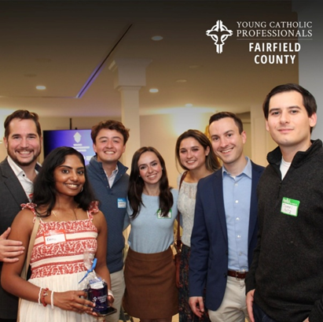
Young Adults United in Christ
Growing up in a deeply faith-filled family, Emma Ratnavel longed for a lifelong community rooted in Christ. After college, a simple invitation from a friend led her to a Young Adult Ministry gathering, an unexpected blessing that reconnected her with peers who desired holiness, authentic friendship, and a vibrant Catholic life.
Through choir, Bible studies, faith-sharing discussions, and joyful fellowship, Emma discovered a place where young adults pray together, support one another, and boldly live out their faith. This ministry also allowed her to share her gifts of music, leadership, and hospitality in service to God and His Church.
The Bishop’s Appeal helps sustain ministries like Young Adult outreach, creating spaces where young Catholics encounter Christ, form lasting community, and grow together as One Church.
Emma’s journey reminds us that when young adults unite in faith, the Lord brings joy, strength, and renewed hope to our parishes.
Make your gift to the Bishop’s Appeal today! Visit: 2026BishopsAppeal.org

