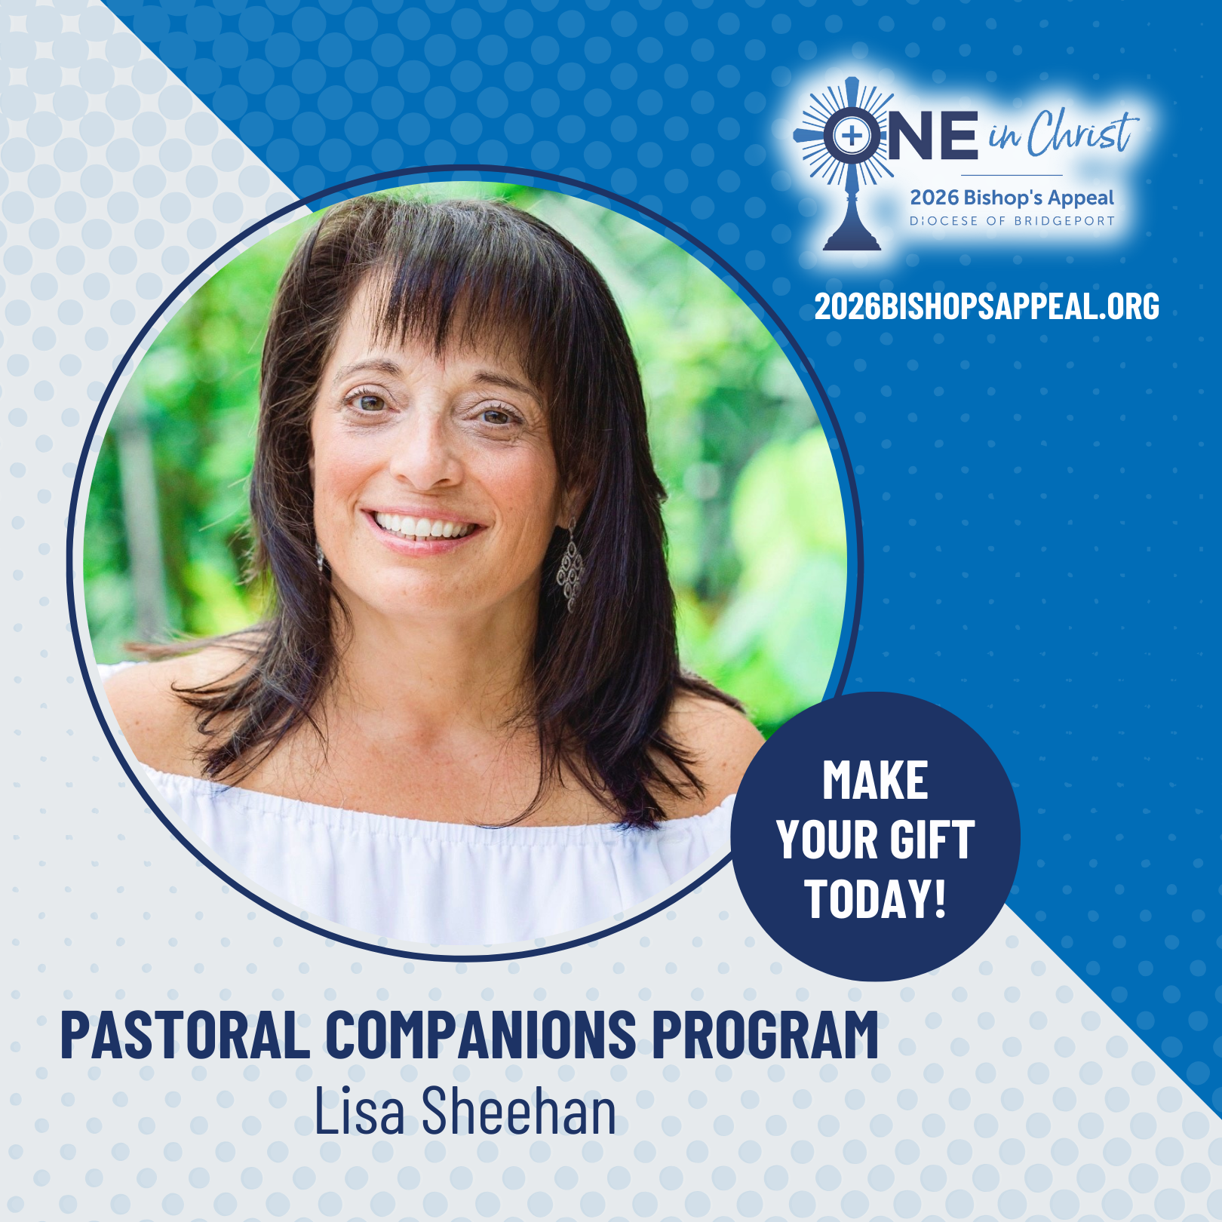
Lisa Sheehan is one of many who serves in the Pastoral Companions program, visiting parishioners in their homes, nursing facilities, and hospitals. 🏡💒
Through prayer, Scripture, and sharing the Eucharist, these companions bring comfort, connection, and community to those who are homebound or in need. ✝️ From celebrating birthdays to accompanying someone in their final days, each visit is a ministry of love and faith in action. 💛
The program not only strengthens the faith of those visited but also enriches the lives of the companions themselves, deepening their relationship with Christ and their parish community. 🙏
Acts of service like these are the heart of The One initiative, reminding us of Matthew 25:40: “Whatever you did for the least of my brothers and sisters, you did for me.” 🌟
The Bishop’s Appeal helps make ministries like this possible. Make a gift today and support the ongoing pastoral renewal in our Diocese! Visit: 2026BishopsAppeal.org
#2026BishopsAppeal #DioceseofBridgeport #OneinChrist #PastoralCompanions

