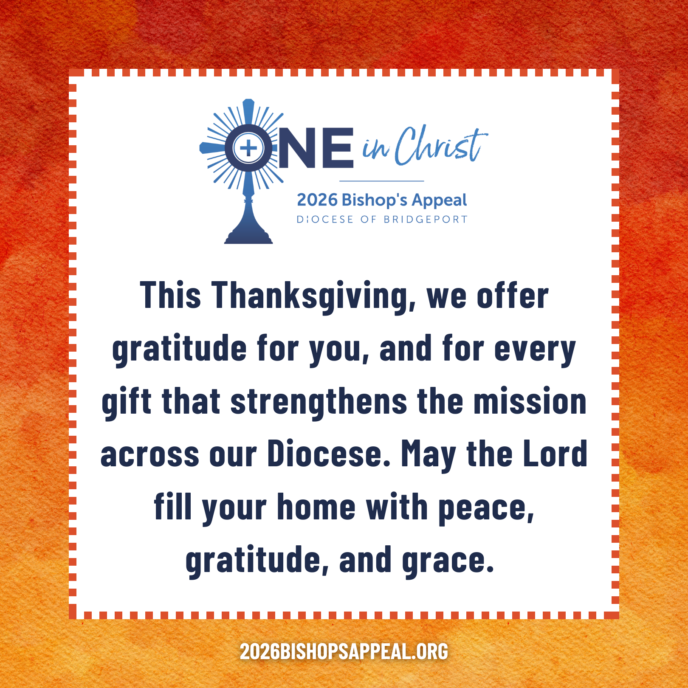
Caption Copy:
As we gather around our tables this Thanksgiving, we pause to remember that every blessing comes from the Lord, who calls us to walk with Him and with one another each day. ✝️💛
Through the 2026 Bishop’s Appeal, our diocesan family unites as One in Christ, supporting ministries that no parish could accomplish alone. Your generosity empowers our Church to:
• 🤝Help our neighbors in crisis through Catholic Charities
• 🙏 Form priests, deacons, and lay leaders
• 👧👦 Nurture children and adults in their growing faith
• 🌟 Support all our families
• 🤝 Bring Christ’s comfort to the grieving, isolated, and ill
• ❤️ And much more!
This Thanksgiving, we offer gratitude for you, and for every gift that strengthens the mission across our Diocese. May the Lord fill your home with peace, gratitude, and grace.
Thank you for walking with us as One in Christ. 🙏 Make your gift to the Bishop’s Appeal today! Visit: 2026BishopsAppeal.org
#2026BishopsAppeal #DioceseofBridgeport #OneinChrist #Thanksgiving

