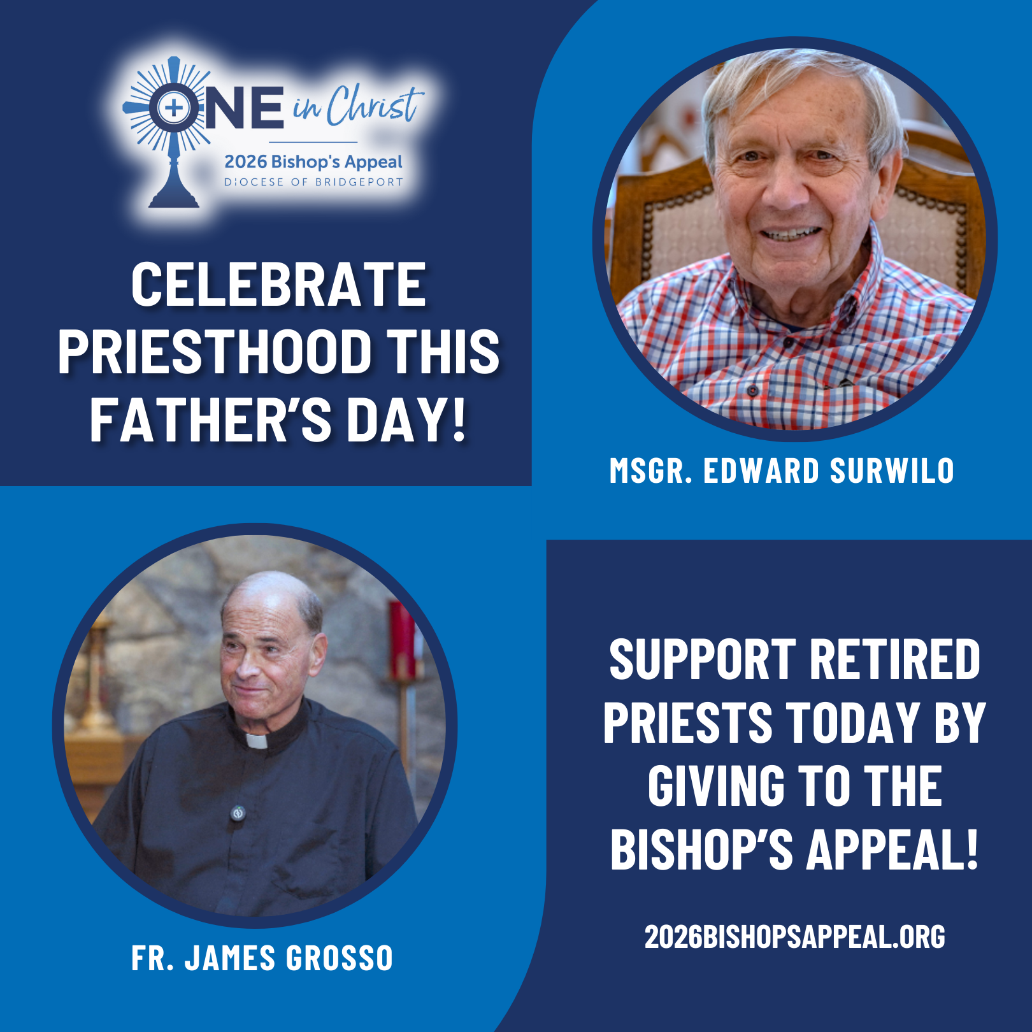
This Father’s Day, we celebrate the gift of priesthood and the faithful service of priests who guide, comfort, and inspire our communities. ✝️
One of our retired priests, Msgr. Edward Surwilo, has served the Diocese for 61 years, offering presence and care to countless families, from baptisms to funerals, and still serves in retirement, celebrating Mass, funerals, and supporting parish life. 🙏💒
Another priest of ours, Fr. James Grosso, now retired, pastored St. Leo Parish for decades and cherishes the joy of ministry: celebrating sacraments, supporting families, and sharing in the life of the Church. Even in retirement, he continues to bring Christ to the faithful. ✨💖
Lives like theirs remind us that priesthood is a vocation of love, service, and presence. The Bishop’s Appeal supports retired priests like Msgr. Surwilo, Fr. Grosso, and many others, while also helping to form the next generation of vocations, ensuring that communities continue to experience Christ’s love through pastoral care.🌟 Support retired priests today by giving to the Bishop’s Appeal! Visit: 2026BishopsAppeal.org

