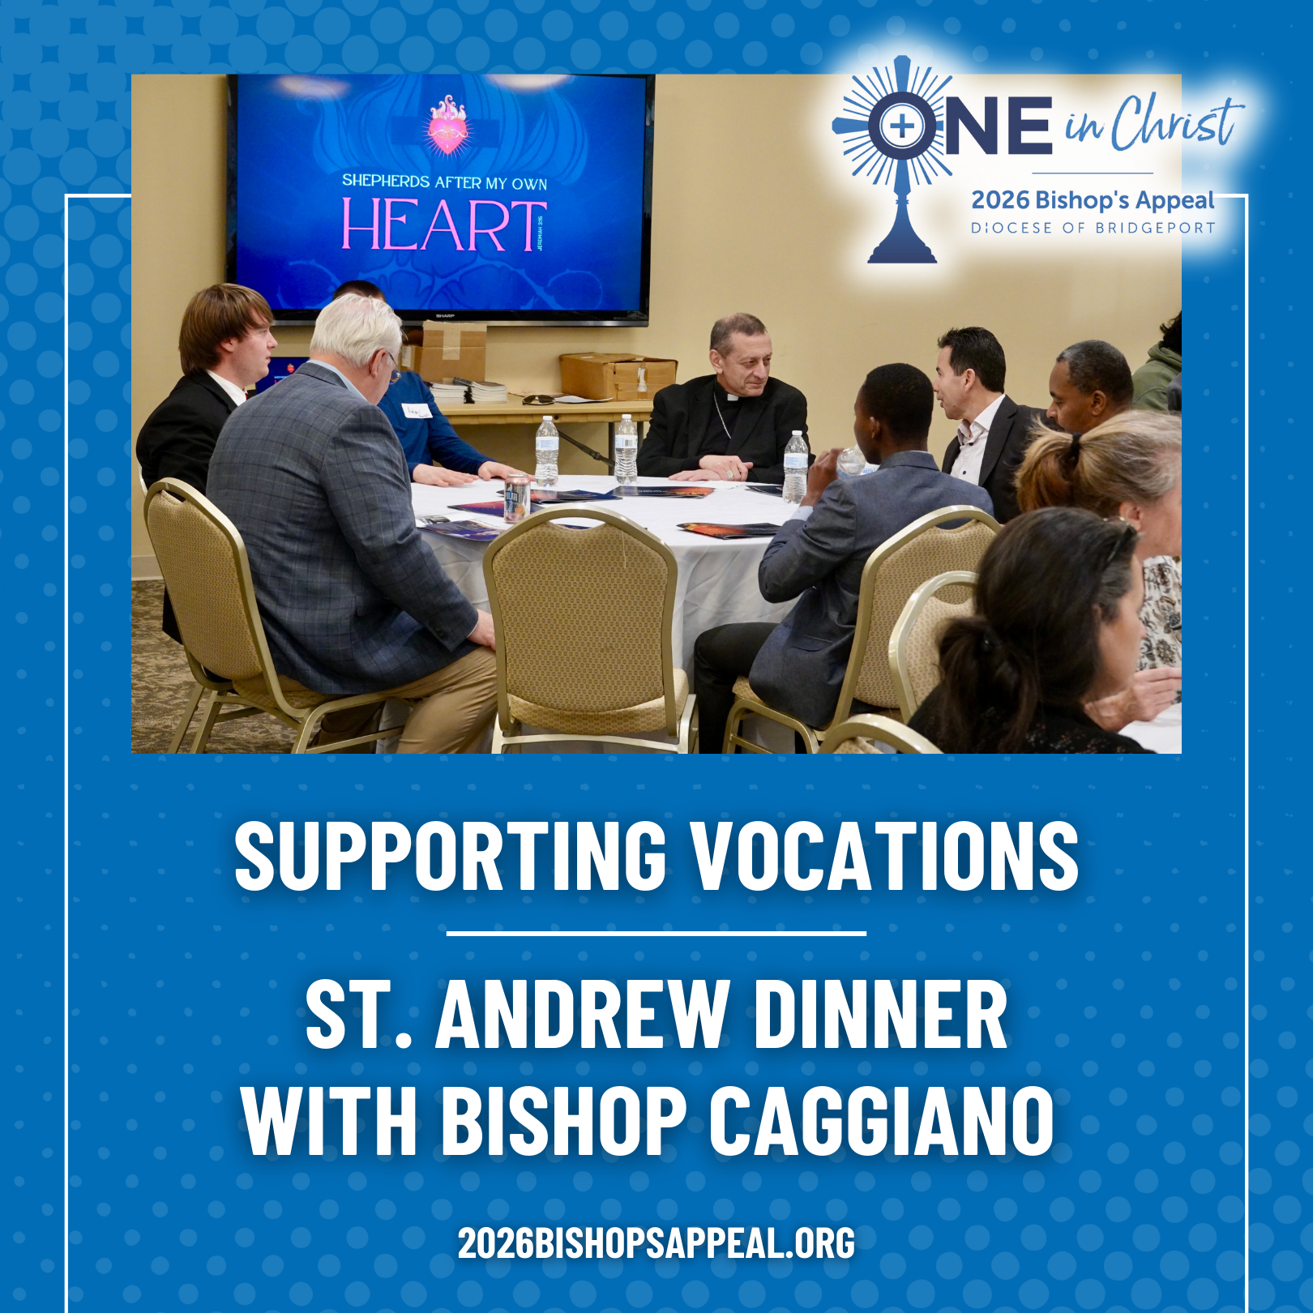
This past fall, a diverse group of young men ranging from teachers, students, engineers, a zoo staffer, a woodworker, a recent convert from Hinduism, and more, gathered with Bishop Frank J. Caggiano for a powerful St. Andrew Dinner. 🙏✨
Together they prayed, shared a meal, and spoke openly about discernment and the possibility of priesthood. Bishop Caggiano encouraged them to rediscover the gift of silence and listen deeply for the Lord’s voice: “God has already chosen the better path—our task is to hear it.”
Your generosity to the Bishop’s Appeal makes moments like this possible by supporting seminarians, vocation programs, and the ongoing work of forming future priests. 💒🔥
Support future vocations today! Visit: 2026BishopsAppeal.org
#2026BishopsAppeal #DioceseofBridgeport #OneinChrist #Vocations

