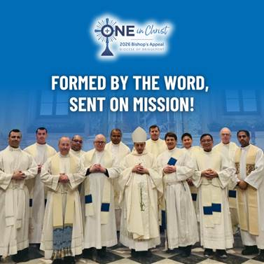
Two years into The One, the Diocese is witnessing powerful renewal, most clearly through the new St. Jerome Center for Preaching and Biblical Studies. ✨ Rooted in the belief that strong preaching leads to conversion, the Center is forming clergy and laity to engage the Word of God more deeply and live as missionary disciples. 📖🔥
By supporting deacons at national preaching and biblical conferences, the Center is expanding opportunities for spiritual growth and strengthening the Church’s witness. 🙏✨ Already, its work is shaping a culture of encounter, discipleship, and evangelization across the Diocese. 🌟
The Bishop’s Appeal helps make this transformation possible, advancing The One’s mission to bring every believer closer to Christ through truth, beauty, and goodness. ✝️💛
Make your gift to the Bishop’s Appeal today! Visit: 2026BishopsAppeal.org
#2026BishopsAppeal #DioceseofBridgeport #OneinChrist #MissionaryDisciples

