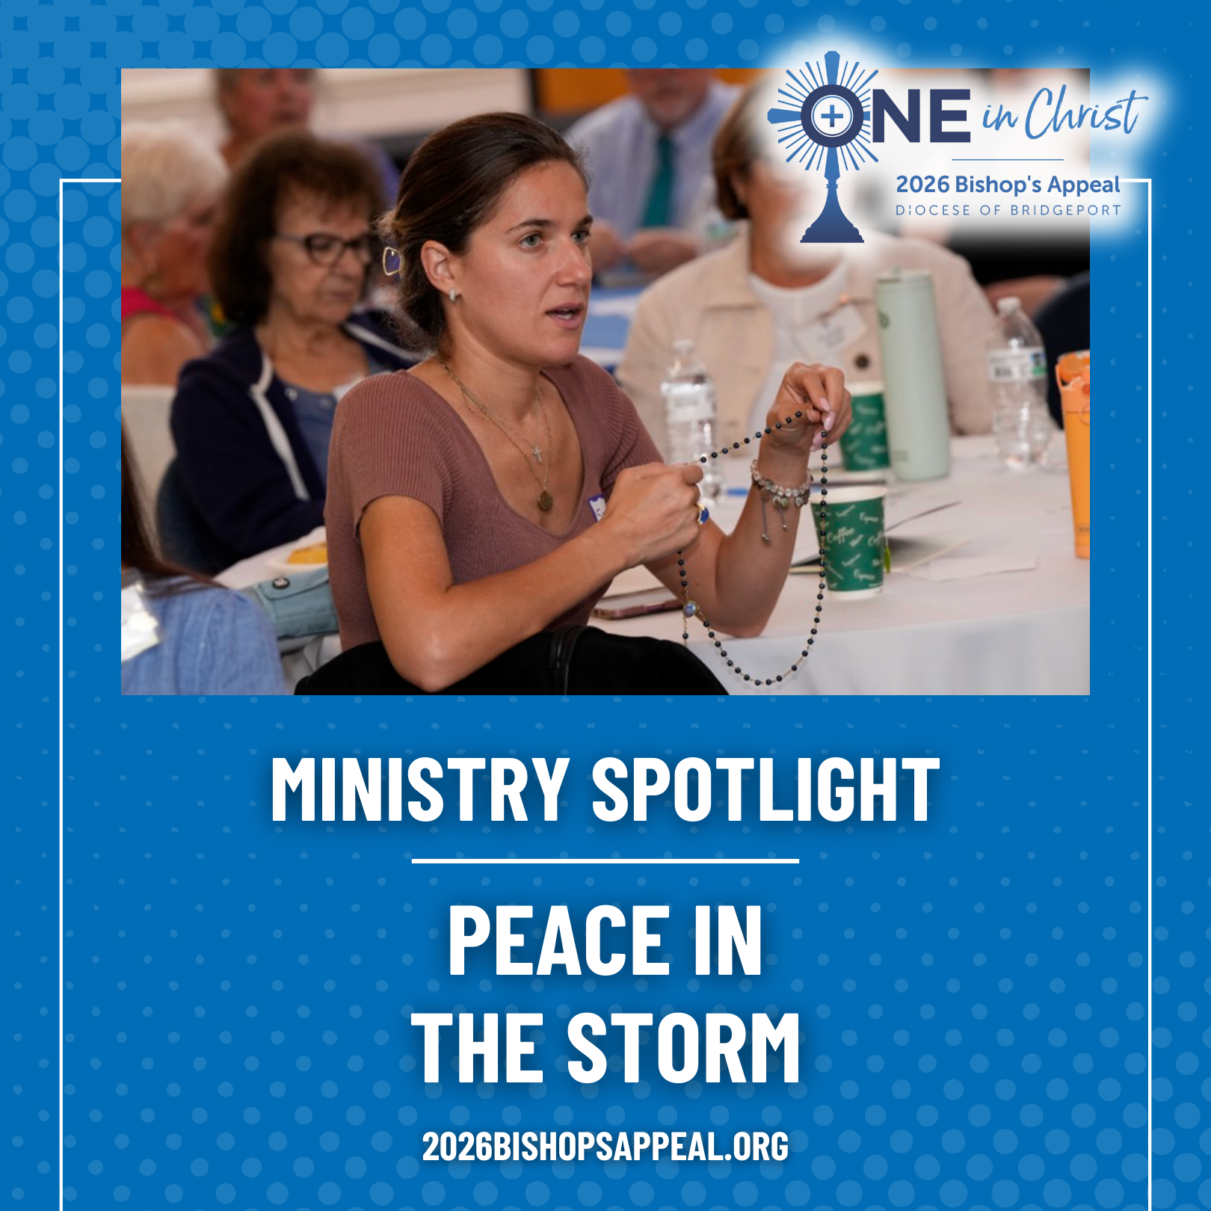
During the pandemic, Pat Calanca and Fr. David Roman launched Peace in the Storm at St. Aloysius in New Canaan, a spiritual support group for parishioners facing health challenges and for caregivers seeking strength. Using the “Peace in the Storm” book as their guide, the group meets monthly for prayer, discussion, and faith-filled fellowship.
This lay-led ministry requires no special training and has become a powerful expression of accompaniment, the heart of the Bishop’s Appeal, One in Christ.
Thanks to the Bishop’s Appeal, ministries like Peace in the Storm continue to grow, offering hope, community, and spiritual support to those who need it most.
Make your gift to the Bishop’s Appeal today! Visit: 2026BishopsAppeal.org
#2026BishopsAppeal #DioceseofBridgeport #OneinChrist #PeaceintheStorm

