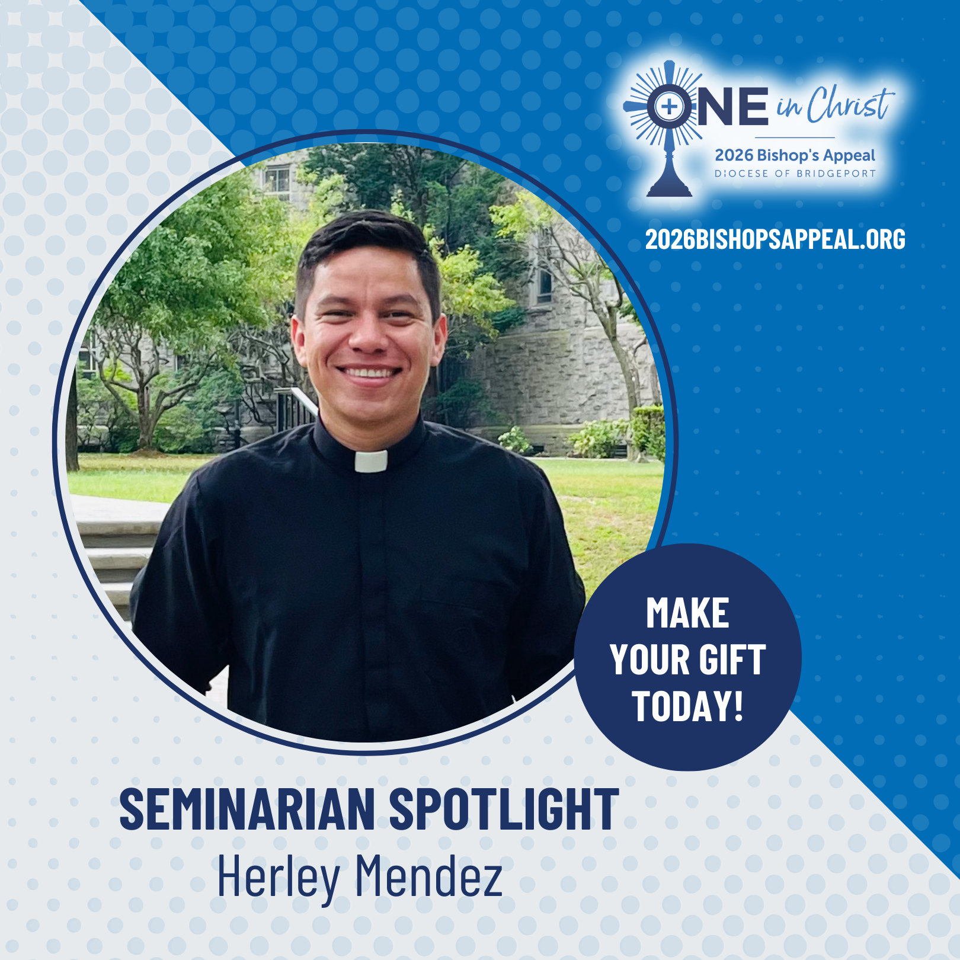
From childhood Masses to mission trips in remote villages, God has guided Herley Mendez’s call to the priesthood. Through his family, pastors, seminary faculty, and especially the support of Bishop Cagliano, he grew in faith, fraternity, and joyful service.
The seminary has transformed his life, teaching him to trust in God, deepening his prayer, and preparing his heart to serve God’s people. Your generosity to the Bishop’s Appeal makes this formation possible and helps future priests walk with God’s people and bring them to Christ.
Thank you for supporting our vocations. Please continue to pray for Herley and for all seminarians. ✝️🙏
Make your gift to the Bishop’s Appeal today! Visit: 2026BishopsAppeal.org
#2026BishopsAppeal #DioceseofBridgeport #OneinChrist #PrayForOurSeminarians

