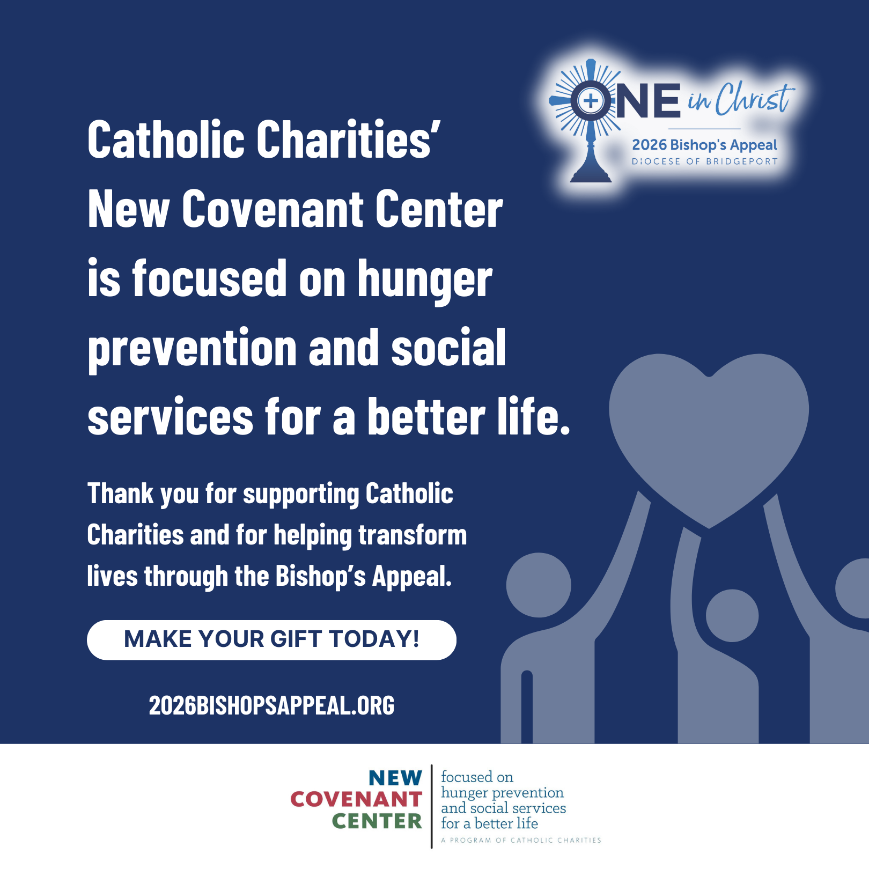
Aaron lost his job and his home, leaving him hurt, overwhelmed, and unsure where to turn. But through the support of Catholic Charities’ New Covenant Center in Stamford, he found compassionate accompaniment on his journey forward. ❤️‍🩹🏠
Staff walked with him as he searched for housing, regained focus, and re-entered the job market. Today, he has a new apartment and renewed hope, thanks to their guidance and the programs that support those who are unhoused, seeking employment, and ready to rebuild their lives. 🙌✨
Stories like Aaron’s are made possible through the Bishop’s Appeal. Your generosity helps accompany neighbors in crisis and transform lives every day. 💙🙏
Support Catholic Charities by making your gift to the Bishop’s Appeal today! Visit: 2026BishopsAppeal.org
#2026BishopsAppeal #DioceseofBridgeport #OneinChrist #CatholicCharities

