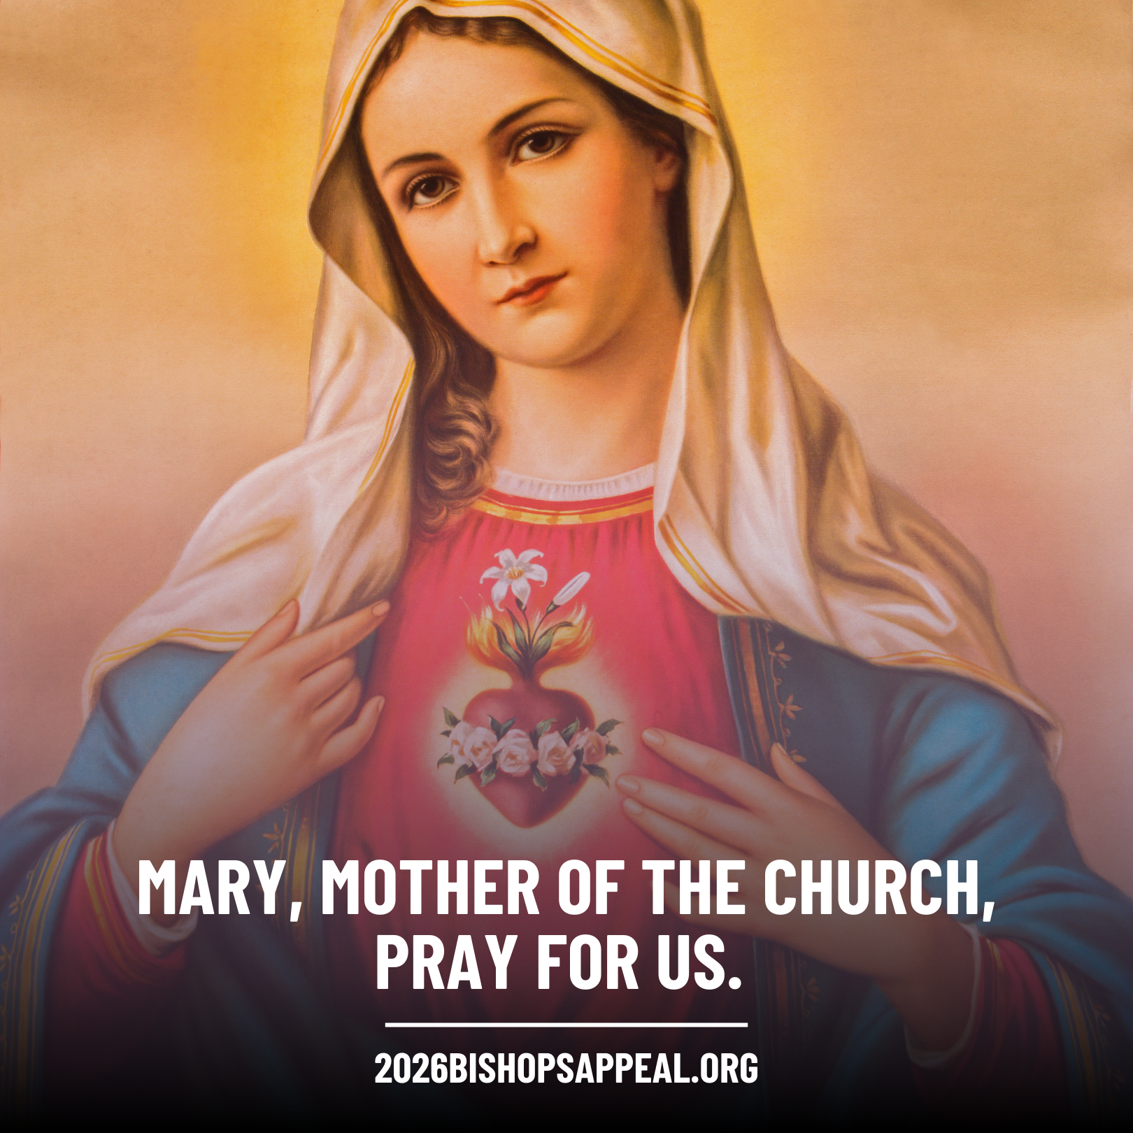
During the month of May, we turn our hearts to Mary, our Mother, who faithfully said “yes” to God and continues to guide us closer to her Son. ✝️💙
As we honor Mary’s example of trust, courage, and discipleship, we also pray for those discerning their own “yes” to God’s call, especially our seminarians and all discerning vocations. 🌿
Through the 2026 Bishop’s Appeal, our diocesan family supports the formation of future priests, the nurturing of faith in our parishes and schools, and ministries that bring Christ’s love to those most in need. Your generosity helps others follow Mary’s example of openness to God’s plan.
Mary, Mother of the Church, pray for us. 🙏🌹
💙 Make your gift to the Bishop’s Appeal today! Visit: 2026BishopsAppeal.org
#2026BishopsAppeal #DioceseofBridgeport #OneinChrist #MonthofMary

