JANUARY BULLETINS
BULLETIN #1 | Introduction to the Bishop’s Appeal | RECOMMENDED BULLETIN WEEKEND: | January 31-February 1
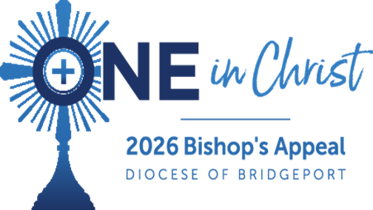
2026 Bishop’s Appeal — One in Christ
The Bishop’s Appeal invites us to live out “The One,” our diocesan vision of spiritual and pastoral renewal. United as One in Christ, we support ministries that accompany others in faith, reflect truth, beauty and goodness and serve those in need throughout Fairfield County.
Your generosity helps the Diocese to:
• Form priests, deacons, and laity to preach, lead, and evangelize more effectively
• Provide tuition assistance in partnership with Foundations in Education for families seeking a Catholic education
• Provide faith formation for all our diocesan communities
• Offer pastoral care to the isolated, grieving, and ill
• Assist individuals and families in crisis through Catholic Charities and other outreach programs
• Provide tuition assistance in partnership with Foundations in Education for families seeking a Catholic education.
Your contribution is a living sign of our unity and strengthens the mission of the Church. Gifts may be made using your parish’s pledge materials or online.
As we continue our journey in life, may we walk One in Christ, accompanying one another and those most in need. Be assured of our prayers for you and your loved ones. Make a gift today: 2026BishopsAppeal.org

FEBRUARY BULLETINS
BULLETIN #2 | Seminarian Spotlight - Herley Mendez Torres | RECOMMENDED BULLETIN WEEKEND: | February 14-15
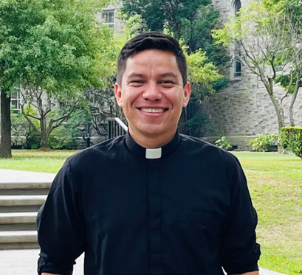
Supporting Vocations: A Call Answered
From childhood Masses to mission trips in remote villages, God has been faithfully guiding Herley Mendez Torres’ call to the priesthood. Through the love and encouragement of his family, parish pastors, seminary faculty, and especially the support of Bishop Cagliano, Herley has grown in faith, fraternity, and joyful service to God’s people.
The seminary has transformed his life, teaching him to trust more deeply in God, strengthening his prayer, and preparing his heart to serve the Church. This vital formation is made possible through the generosity of the faithful.
Your support of the Bishop’s Appeal helps form future priests, ensuring they are prepared to walk with God’s people and lead them to Christ.
Thank you for supporting vocations in our diocese. Please continue to pray for Herley and for all our seminarians as they discern and respond to God’s call.
Support our seminarians today! Visit: 2026BishopsAppeal.org

FEBRUARY BULLETINS
BULLETIN #3 | Lent | RECOMMENDED BULLETIN WEEKEND: | February 21-22

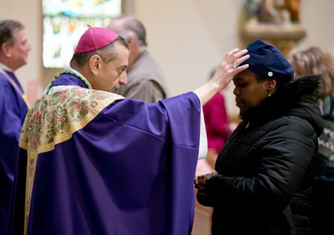
Lent: A Journey of Hope
As we enter the holy season of Lent, the Church invites us to deepen our lives of prayer, fasting, and almsgiving. These sacred practices draw us closer to Christ and strengthen our communion with one another.
Lent is a journey of the heart, a time to reflect on God’s mercy, renew our commitment to the Gospel, and grow in hope. This hope is not meant to be kept to ourselves; it reaches out, lifts up, and transforms lives.
United as One in Christ, we are called to share this hope with our brothers and sisters throughout our diocese. As you prayerfully make your Lenten sacrifices, please consider offering a gift to the Bishop’s Appeal. Your generosity becomes a living sign of hope and a witness to our shared mission as the Church.
Be assured of our prayers as you begin your Lenten journey. May this season draw us ever closer to Christ and to one another.
Make your gift to the Bishop’s Appeal today! Visit: 2026BishopsAppeal.org

MARCH BULLETINS
BULLETIN #4: | Young Adult Spotlight - Emma | RECOMMENDED BULLETIN WEEKEND: | March 7-8
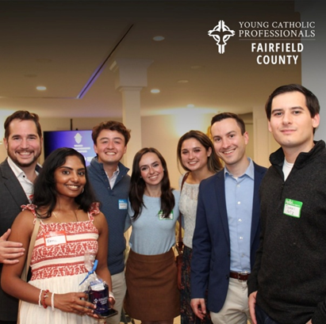
Young Adults United in Christ
Growing up in a deeply faith-filled family, Emma Ratnavel longed for a lifelong community rooted in Christ. After college, a simple invitation from a friend led her to a Young Adult Ministry gathering, an unexpected blessing that reconnected her with peers who desired holiness, authentic friendship, and a vibrant Catholic life.
Through choir, Bible studies, faith-sharing discussions, and joyful fellowship, Emma discovered a place where young adults pray together, support one another, and boldly live out their faith. This ministry also allowed her to share her gifts of music, leadership, and hospitality in service to God and His Church.
The Bishop’s Appeal helps sustain ministries like Young Adult outreach, creating spaces where young Catholics encounter Christ, form lasting community, and grow together as One Church.
Emma’s journey reminds us that when young adults unite in faith, the Lord brings joy, strength, and renewed hope to our parishes.
Make your gift to the Bishop’s Appeal today! Visit: 2026BishopsAppeal.org

MARCH BULLETINS
BULLETIN #5: | Catholic Charities Spotlight | RECOMMENDED BULLETIN WEEKEND: | March 21-22
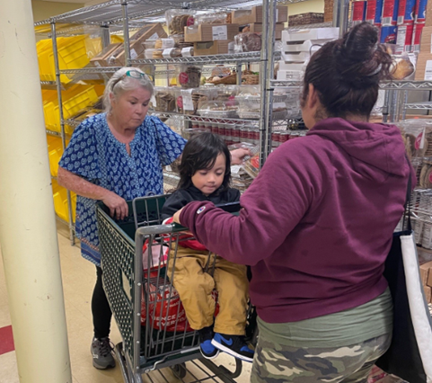
Accompanying Neighbors in Need
After losing his job and his home, Aaron felt overwhelmed and unsure where to turn. Through the compassionate outreach of Catholic Charities’ New Covenant Center in Stamford, he found hope and someone to walk with him on his journey forward.
Dedicated staff accompanied Aaron as he searched for housing, regained stability, and re-entered the job market. With their guidance and support, he now has a new apartment and renewed hope for the future. His story reflects the life-changing impact of programs that serve those who are unhoused, seeking employment, and ready to rebuild their lives.
Stories like Aaron’s are made possible through the Bishop’s Appeal. Your generosity helps ensure that our neighbors in crisis are met with dignity, compassion, and the love of Christ.
Thank you for supporting Catholic Charities and for helping transform lives through the Bishop’s Appeal.
Make your gift to the Bishop’s Appeal today! Visit: 2026BishopsAppeal.org

APRIL BULLETINS
BULLETIN #6: | Ministry Spotlight- Ambassador Program | RECOMMENDED BULLETIN WEEKEND: | April 11-12
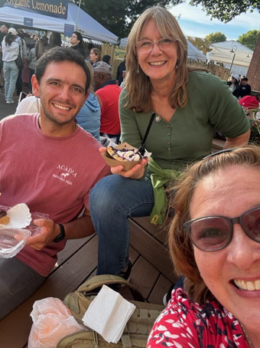
Ambassadors: Sharing Faith, Building Community
In 2020, Cate Gosselin joined the Ambassadors Program to help rebuild parish life and share the faith with others. Guided by Monsignor Weiss and supported by God, she now participates in formation, fellowship, and welcoming new parishioners.
Through monthly gatherings, after-Mass coffee and fellowship, and family events, Ambassadors like Cate help others return to their faith while fostering a warm, supportive parish community. As Cate says, “Every day, we have the chance to serve by sharing our faith story or listening to someone else’s.”
This ministry reflects the Bishop’s Appeal theme, One in Christ, bringing parishioners together to renew and strengthen the Church.
Support programs like the Ambassadors Ministry and more through your gift to the Bishop’s Appeal. Visit: 2026BishopsAppeal.org

APRIL BULLETINS
BULLETIN #7: | Deacon Spotlight- Dcn. David Flynn | RECOMMENDED BULLETIN WEEKEND: | April 25-26
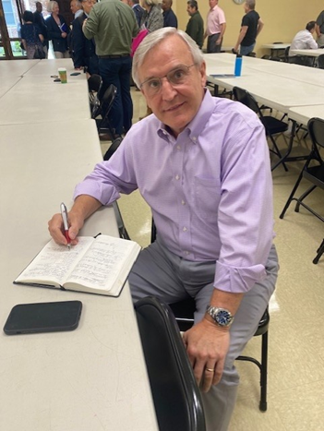
Formed to Serve: Supporting Our Deacons
For years, Deacon David Flynn quietly sensed a call to the diaconate, until a simple question from his sister gave him the confirmation he had long prayed for. Through five and a half years of formation, his wife, Anita, and trusted spiritual guides walked with him, teaching that “to preach well, you have to pray.”
Deacon Flynn’s ministry has deepened his relationship with Christ and strengthened his family’s faith. He accompanies parishioners, OCIA candidates, and all who seek a closer encounter with God. Formation programs, retreats, spiritual direction, and diocesan resources continue to nourish his vocation, preparing him to serve as a witness of truth, healing, and unity.
The Bishop’s Appeal supports the formation and ongoing training of deacons like Deacon Flynn, helping them serve the Church’s mission and bringing us together as One in Christ.
Support our deacons today! Visit: 2026BishopsAppeal.org

MAY BULLETINS
BULLETIN #8: | Ministry Spotlight- St. Luke Guild | RECOMMENDED BULLETIN WEEKEND: | May 16-17

St. Luke Guild: Supporting Those Who Serve
Tom Walsh, chaplain at Yale New Haven Hospital, serves in the St. Luke Guild, a ministry dedicated to supporting healthcare providers through prayer, formation, and fellowship.
Guild members participate in:
- Prayerful Encounters and spiritual reflection
- Book discussions on faith in healthcare
- Acts of mercy like food drives and community outreach
Through the Guild, healthcare providers are spiritually strengthened, equipped to serve faithfully, and united as One in Christ.
The Bishop’s Appeal helps make this ministry possible, advancing pastoral renewal in the Diocese by forming disciples who serve others with love and compassion.

Make a gift today: 2026BishopsAppeal.org

JUNE BULLETINS
BULLETIN #9: | Accompaniment | RECOMMENDED BULLETIN WEEKEND: | June 6-7

Walking Together in Faith through Accompaniment
Jesus walked with His disciples, meeting them in their struggles and leading them toward truth. Today, the Church continues this mission through accompaniment, walking alongside one another in faith so that all may encounter Christ.
As Catholics, accompaniment calls us to build meaningful relationships rooted in patience, mercy, service, and authentic love. Through the Church, the Sacraments, and our personal witness, we help others grow in holiness and deepen their communion with God.
Across the Diocese of Bridgeport, many experience loneliness or spiritual disconnection. Through The One, the Diocese responds by offering pastoral accompaniment and home visits through Pastoral Companions, and one on one spiritual friendships through Walk With One.
The Bishop’s Appeal supports these ministries and makes this work possible as we continue growing One in Christ.

Support these ministries by giving today: 2026BishopsAppeal.org

JUNE BULLETINS
BULLETIN #10: | Father’s Day/ Retired Priests | RECOMMENDED BULLETIN WEEKEND: | June 20-21

Celebrate Priesthood This Father’s Day
This Father’s Day, we honor the men who have devoted their lives to Christ and His Church.
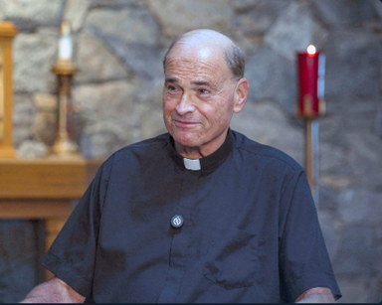
Msgr. Edward Surwilo – 61 years of priestly service, bringing comfort, guidance, and presence to families in Stamford. Even in retirement, he continues to serve, celebrating Mass, funerals, and supporting parish ministries.
Fr. James Grosso – Former pastor of St. Leo Parish, whose decades of ministry brought joy, faith formation, and pastoral care to generations of parishioners. In retirement, he continues to celebrate the sacraments and accompany the faithful.
Their lives remind us of the importance of priestly vocations and the ongoing support they need. The Bishop’s Appeal makes this possible by caring for priests, assisting retired clergy, and supporting the formation of future priests.
Give today to honor priesthood and ensure the next generation of priests is formed in faith and service. Visit: 2026BishopsAppeal.org

JULY BULLETINS
BULLETIN #11: | Vocations | RECOMMENDED BULLETIN WEEKEND: | July 11-12
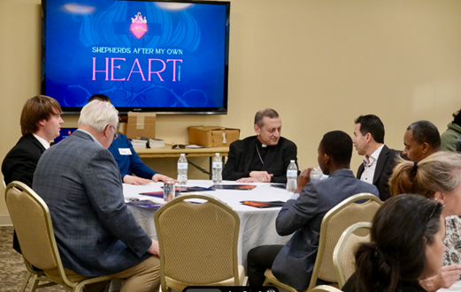
Supporting Vocations: St. Andrew Dinner with Bishop Caggiano
This past fall, a diverse group of young men including teachers, students, engineers, a woodworker, a zoo staff member, and a recent convert to the Catholic faith gathered with Bishop Frank J. Caggiano for a St. Andrew Dinner. Together they shared prayer, fellowship, and honest conversation about discerning God’s call and the possibility of priesthood.
Bishop Caggiano encouraged the men to rediscover the gift of silence and to listen attentively for the Lord’s voice, reminding them, “God has already chosen the better path—our task is to hear it.”
Events like this are made possible through the generosity of those who support the Bishop’s Appeal, which helps fund seminarians, vocation programs, and the formation of future priests.
Please consider supporting future vocations. To make a gift, visit 2026BishopsAppeal.org

JULY BULLETINS
BULLETIN #12: | Ministry Spotlight- St. Jerome Center | RECOMMENDED BULLETIN WEEKEND: | July 25-26
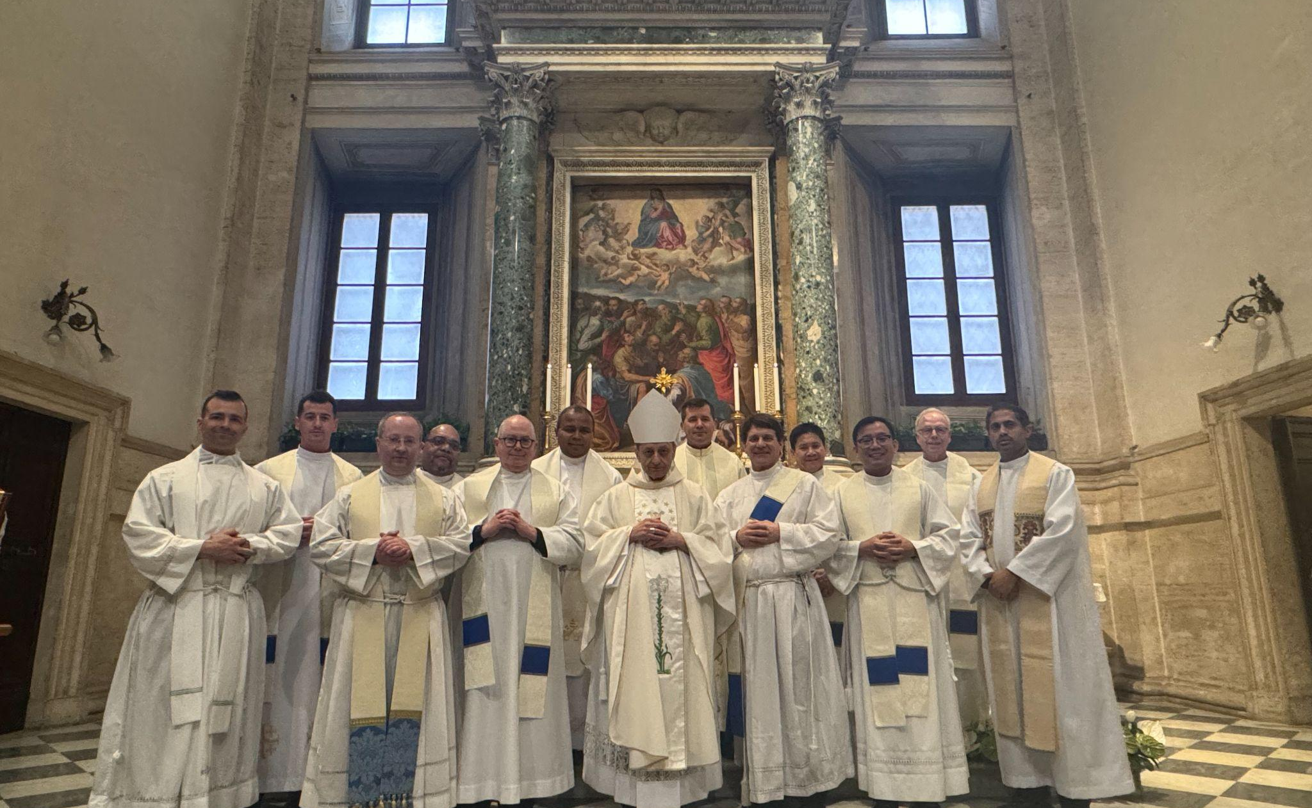
Formed by the Word, Sent on Mission
As the Diocese continues its journey through The One, new efforts are bearing fruit in the renewal of preaching and biblical formation. The St. Jerome Center for Preaching and Biblical Studies has been established to strengthen the proclamation of God’s Word and to help clergy and lay faithful grow in confidence, understanding, and faith.
Through opportunities such as participation in national conferences and ongoing formation, deacons and others are being equipped to preach with clarity and conviction, fostering deeper encounters with Christ within our parishes. This initiative is already enriching diocesan life by encouraging discipleship, evangelization, and a greater love for Sacred Scripture.
The Bishop’s Appeal plays a vital role in supporting this work, helping advance The One’s mission to lead all people closer to Christ through truth, beauty, and goodness.
Please prayerfully consider a gift to the Bishop’s Appeal. More information is available at 2026BishopsAppeal.org

AUGUST BULLETINS
BULLETIN #13: | Young Adult Spotlight- Thomas | RECOMMENDED BULLETIN WEEKEND: | August 8-9

Young Adult Faith in Action
A vibrant young adult ministry in Stamford is helping young Catholics, like Thomas Angiolollo, deepen their faith and find meaningful community within the Church. What began as an invitation to explore fellowship and formation has grown into an active outreach where prayer, Sacred Scripture, service, and shared faith are central.
At Holy Name of Jesus Parish, the monthly Young Adult Mass brings young adults together for Eucharistic adoration, the Sacrament of Reconciliation, the celebration of Mass, and time for fellowship. Through this ministry, participants are discovering a stronger sense of purpose and a deeper relationship with Christ, rooted in community and service.
The Bishop’s Appeal supports young adult ministries like this one, strengthening parish life, fostering unity, and forming future leaders for the Church.
Please consider supporting our young adult community through the Bishop’s Appeal.
Learn more or make a gift at 2026BishopsAppeal.org

AUGUST BULLETINS
BULLETIN #14: | Ministry Spotlight- Peace in the Storm | RECOMMENDED BULLETIN WEEKEND: | August 22-23
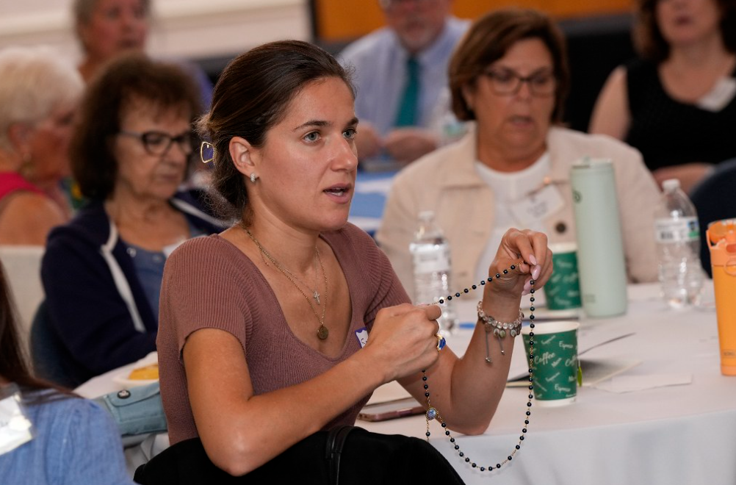
Accompanying One Another in Hope
At St. Aloysius Parish in New Canaan, a monthly spiritual support group offers prayerful encouragement to those living with illness and to caregivers walking alongside them. Founded by parishioner Pat Calanca in collaboration with Fr. David Roman, Peace in the Storm provides a welcoming space where participants reflect on faith, share experiences, and draw strength from one another in Christ.
Guided by the Peace in the Storm resource, this lay-led ministry demonstrates how simple acts of presence, prayer, and listening can become powerful signs of God’s love. Mentorship and training are available and a willingness to accompany others with compassion and faith.
Support from the Bishop’s Appeal, One in Christ, allows ministries like this to continue reaching those in need, strengthening parish life, and bringing comfort to hearts facing difficult moments.
Please consider making a gift to the Bishop’s Appeal. Learn more or donate at 2026BishopsAppeal.org

SEPTEMBER BULLETINS
BULLETIN #15: | Ministry Spotlight- Pastoral Companions Program | RECOMMENDED BULLETIN WEEKEND: | September 12-13

Bringing Christ to Those Most in Need
Through the Pastoral Companions program, parishioners reach out to those who are unable to come to church due to illness, age, or circumstance. Trained lay ministers, like Lisa Sheehan, visit individuals in their homes, hospitals, and care facilities, offering prayer, Scripture, and, when appropriate, Holy Communion.
These visits provide more than companionship. They are moments of grace that bring comfort, dignity, and a living connection to the parish community. Whether sharing in life’s milestones or offering a prayerful presence during times of suffering, Pastoral Companions witness Christ’s love through faithful service.
This ministry reflects the heart of The One initiative, calling the Church to serve Christ by serving one another. Support from the Bishop’s Appeal makes this pastoral outreach possible, helping parishes care for those who are most vulnerable.
Help bring Christ to those in need through the Bishop’s Appeal. More information is available at 2026BishopsAppeal.org

SEPTEMBER BULLETINS
BULLETIN #16: | Seton Collaborative | RECOMMENDED BULLETIN WEEKEND: | September 16-27

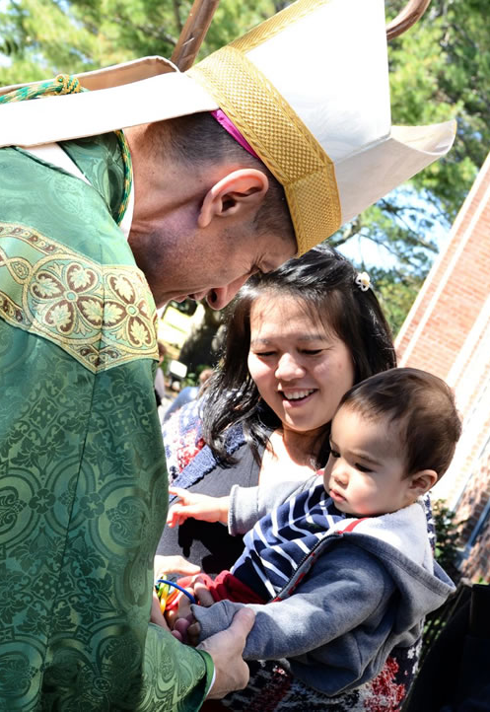
Strengthening Parishes and Schools through the Seton Collaborative
The Seton Collaborative is a new diocesan nonprofit created to strengthen our parishes and schools by transforming how they operate so they can better serve their communities and support both academic excellence and spiritual growth.
By identifying efficiencies, standardizing and automating processes, sharing best practices, developing staff, and leveraging economies of scale, the Seton Collaborative helps ministries focus more fully on their mission of forming disciples and educating future generations.
The mission of the Seton Collaborative is to promote growth and innovation in schools and parishes by contributing expertise, creativity, resources, and capital to drive renewal across the Diocese of Bridgeport.
As Bishop Frank J. Caggiano reminds us,
“For the Church to be renewed, we must unlock the talents that have been given to us. And for the Church to grow, we need to collaborate.”
Through the Bishop’s Appeal One in Christ, your support makes this vital work possible.
Learn more at 2026BishopsAppeal.org

OCTOBER BULLETINS
BULLETIN #17: | Diaconate Spotlight- Andres Grajales | RECOMMENDED BULLETIN WEEKEND: | October 10-11
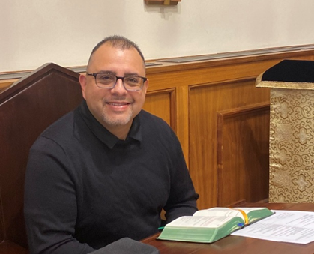
Answering God’s Call to Serve
For Andres Grajales, the call to the diaconate came quietly but unmistakably, encouraged by three different priests and supported by his family, parish community, and the Charismatic Renewal. Entering formation has been a deeply rewarding journey, allowing him to grow in faith and prepare to serve others.
Andres hopes to reflect Christ’s love as a deacon, bringing His light both to the Church and to those who have not yet encountered Him, fostering unity and renewal in the Diocese.
The Bishop’s Appeal helps make diaconate formation possible, providing education, spiritual guidance, and pastoral training for men discerning this sacred vocation.
Support the next generation of deacons by giving to the Bishop’s Appeal.
Learn more at 2026BishopsAppeal.org

OCTOBER BULLETINS
BULLETIN #18: | Apologetics Spotlight | RECOMMENDED BULLETIN WEEKEND: | October 24-25
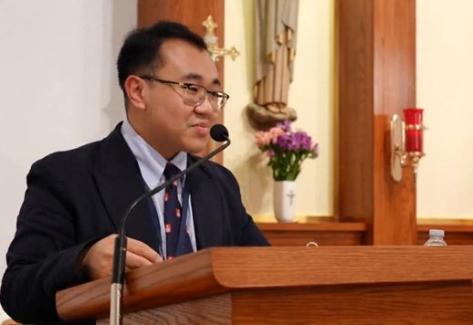
Apologetics: Strengthening Faith for Today’s World
In today’s world, Catholics are called not only to believe, but to understand and share their faith with clarity, confidence, and charity. The Diocese of Bridgeport is supporting this mission through the work of Suan Sonna, Director of Apologetics.
Suan’s ministry focuses on helping Catholics:
- Understand what we believe and why
- Encounter Christ more deeply
- Respond to questions about the faith with care and compassion
Guided by the principles of Fidelity, Integrity, Rigor, and Empathy, this office offers retreats, mentorship, youth programs, and testimony nights that form thoughtful, confident disciples.
The Bishop’s Appeal makes this important work possible, supporting initiatives that strengthen faith and equip Catholics to engage the culture with truth and charity.
Please consider making a gift to the Bishop’s Appeal. Learn more at 2026BishopsAppeal.org

OCTOBER/NOVEMBER BULLETINS
BULLETIN #19: | National Vocation Awareness Week Spotlight | RECOMMENDED BULLETIN WEEKEND: | October 31-November 1
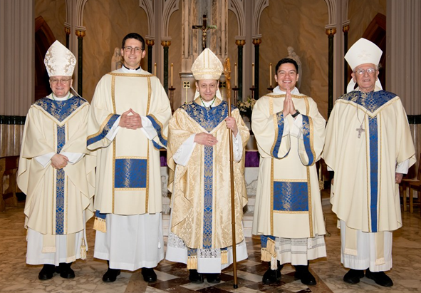
Celebrating Vocations: Saying “Yes” to God’s Call
This week, we honor those who are listening to God’s call and courageously saying “Yes” to lives of service. Whether called to the priesthood, religious life, marriage, or dedicated single life, each vocation is a gift that strengthens the Body of Christ.
Through the 2026 Bishop’s Appeal, the Diocese provides support for the formation of future priests and Catholic leaders, offering guidance, education, and spiritual formation to help them discern their vocation with confidence and hope.
Please join us in praying for holy, joyful, and generous vocations: Lord, open hearts to Your call and guide Your people to their true purpose.
Support the next generation of Church leaders by giving to the Bishop’s Appeal.
Learn more at 2026BishopsAppeal.org

DECEMBER BULLETINS
BULLETIN #20: | End of Year Thank You | RECOMMENDED BULLETIN WEEKEND: | December 26-27

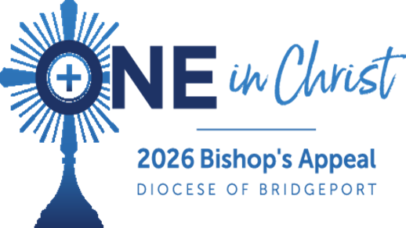
Gratitude for Your Support of the Bishop’s Appeal
As the year draws to a close, the Diocese of Bridgeport gives thanks for the generosity and faith of our parishioners. Because of your support of the Bishop’s Appeal, countless lives have been touched across our Diocese:
- Neighbors in need have received hope and assistance through Catholic Charities
- Seminarians continue to answer God’s call to the priesthood
- Young adults are finding community and spiritual growth
- Deacons and lay leaders are growing in formation and service
- Families are strengthened through youth ministry and pastoral accompaniment
- Retired priests are cared for with dignity and love

Every ministry, vocation, and act of mercy is made possible because our diocesan community walks One in Christ.

Thank you for your prayers, generosity, and witness of faith. Together, we continue to bring Christ’s love to every corner of Fairfield County.

