Diocese of Bridgeport
Social Media Content Guide
2026 Bishop’s Appeal: One in Christ

Introduction
The following provides ready-to-use social media posts for the Diocese of Bridgeport and its parishes to support the 2026 Bishop’s Appeal. Each post is crafted to inspire parishioners to participate, deepen their understanding of the ministries they are supporting, and strengthen engagement throughout the campaign.
You may follow the recommended social media calendar or share posts according to your parish’s schedule. All materials are designed to increase awareness, encourage generosity, and unify our message during this year’s appeal.
Each post includes:
• A graphic suitable for both Facebook and Instagram
• A caption formatted for use on either platform
Please keep in mind:
• Instagram captions do not support clickable links; Facebook does support clickable links
• Consider adding the Bishop’s Appeal giving link to your Instagram bio for easier access
Thank you for helping us share the message of faith, generosity, and community through this year’s Bishop’s Appeal.
Thank you, and God bless!

JANUARY POSTS
POST #1 TOPIC: | Introduction to the Bishop’s Appeal | RECOMMENDED POST DATE: | Monday, January 26
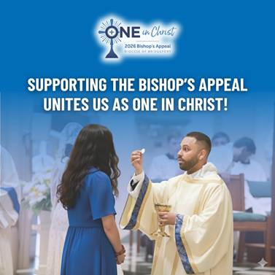
Caption Copy:
Each day, the Lord calls us to walk with Him and with one another. Through the 2026 Bishop’s Appeal, our diocesan family unites as One in Christ to support ministries no single parish can provide. ✝️💛
Your generosity helps us:
• 🙏 Form priests, deacons, and lay leaders
• 👧👦 Support children and adults growing in their faith
• 🌟 Accompany all families
• 🤝 Bring Christ’s healing to the isolated, grieving, and ill
• ❤️ Serve individuals and families in crisis
• 📚 Provide tuition assistance for Catholic education
Every gift strengthens our mission throughout Fairfield County. 💒 May we continue walking as One in Christ, serving those in need and growing as true disciples.
Learn more and make your gift today by visiting : 2026BishopsAppeal.org
#2026BishopsAppeal #DioceseofBridgeport #OneinChrist
FEBRUARY POSTS
POST #2  TOPIC: | Seminarian Spotlight - Herley Mendez | RECOMMENDED POST DATE: | Tuesday, February 10
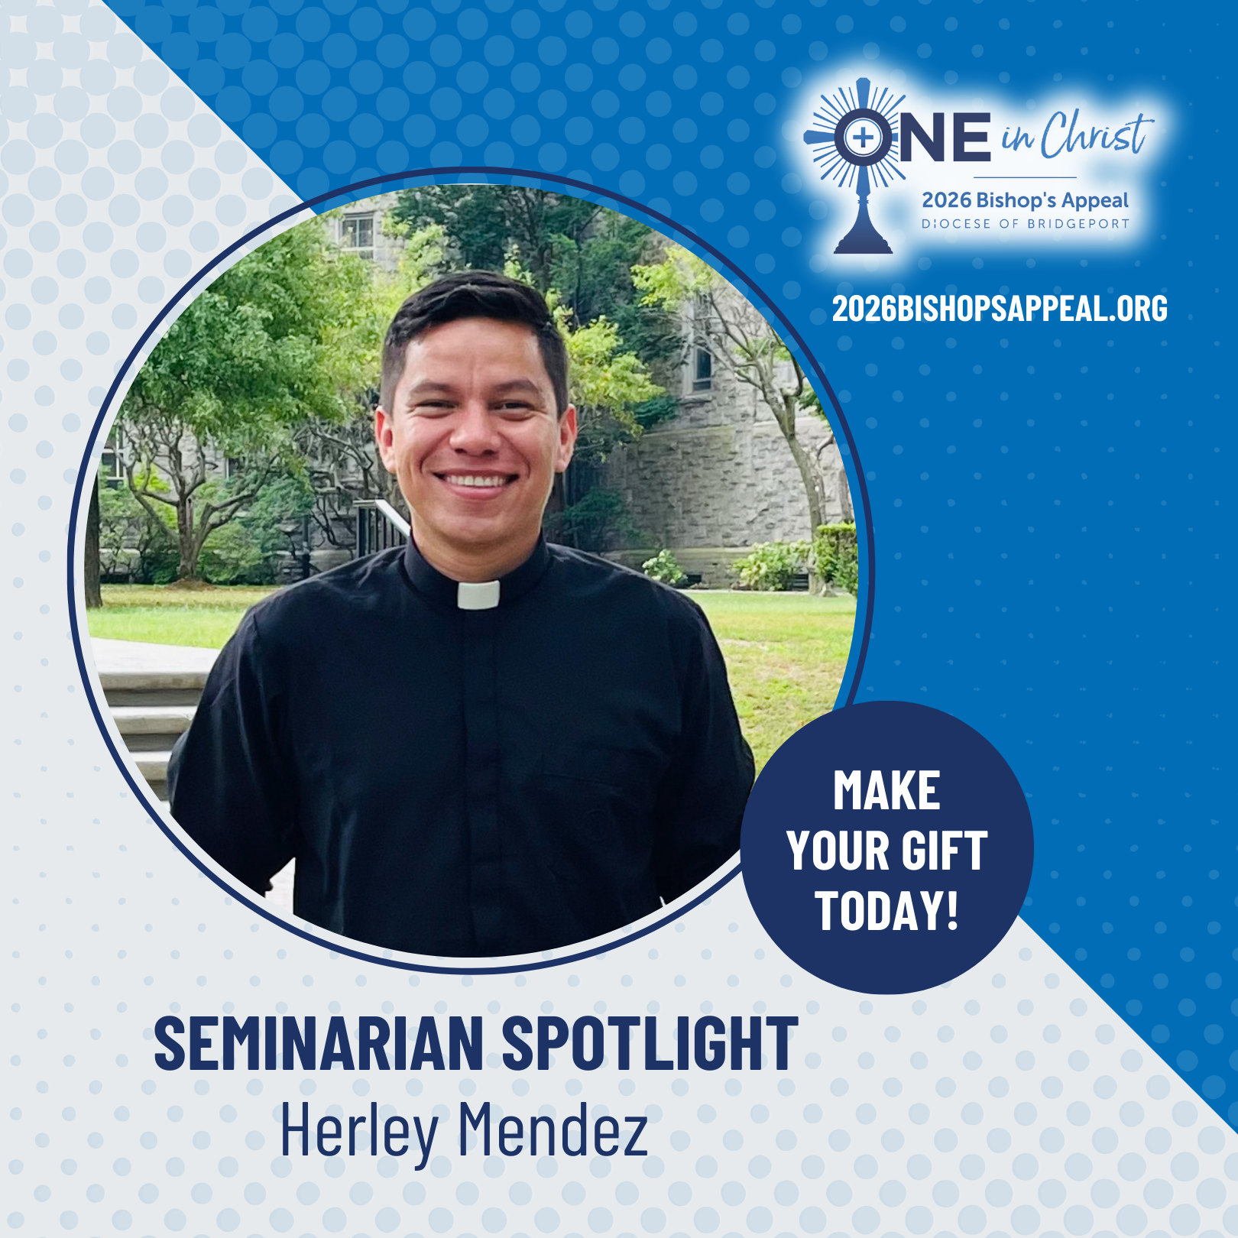
Caption Copy
From childhood Masses to mission trips in remote villages, God has guided Herley Mendez’s call to the priesthood. Through his family, pastors, seminary faculty, and especially the support of Bishop Cagliano, he grew in faith, fraternity, and joyful service.
The seminary has transformed his life, teaching him to trust in God, deepening his prayer, and preparing his heart to serve God’s people. Your generosity to the Bishop’s Appeal makes this formation possible and helps future priests walk with God’s people and bring them to Christ.
Thank you for supporting our vocations. Please continue to pray for Herley and for all seminarians. ✝️🙏
Make your gift to the Bishop’s Appeal today! Visit: 2026BishopsAppeal.org
#2026BishopsAppeal #DioceseofBridgeport #OneinChrist #PrayForOurSeminarians

FEBRUARY POSTS
POST #3 TOPIC: | Lent | RECOMMENDED POST DATE: | Wednesday, February 18 (Ash Wednesday)
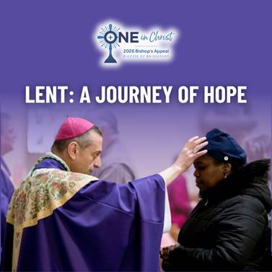
Caption Copy:
As we enter the season of Lent, we’re reminded of the call to prayer, fasting, and almsgiving, practices that draw us closer to Christ and to one another. This holy season invites us to journey inward, reflect on God’s mercy, and renew our commitment to live the Gospel more fully.
Lent is a journey of the heart, a time filled with hope. A hope that reaches out, lifts up, and transforms the lives of those around us. United as One in Christ, we are called to share that hope with our brothers and sisters.
As you make your Lenten sacrifices, please consider offering a gift to the Bishop’s Appeal. Your generosity becomes more than an act of giving; it becomes a living sign of hope and a witness to our unity as One in Christ. We are praying for you as you begin your Lenten journey.
Make your gift to the Bishop’s Appeal today! Visit: 2026BishopsAppeal.org
#2026BishopsAppeal #DioceseofBridgeport #OneinChrist #AshWednesday

MARCH POSTS
POST #4 TOPIC: | Young Adult Ministry Spotlight – Emma Ratnavel | RECOMMENDED POST DATE: | Thursday, March 5

Caption Copy:
Growing up in a deeply faith-filled family, Emma Ratnavel always longed for lifelong community in Christ. After college, a friend invited her to a Young Adult Ministry event, an unexpected blessing that reunited her with peers who also desired holiness and authentic Catholic friendship.
Through choir, Bible studies, faith discussions, and even joyful events like skating and dancing, she found a place where young adults support one another, pray together, and boldly live out their faith. The ministry has allowed her to use her gifts—music, leadership, hospitality—to glorify God and inspire others to pursue Christ wholeheartedly.
The Bishop’s Appeal helps sustain ministries like Young Adult outreach, creating spaces where young Catholics encounter Christ, form lasting communities, and grow as one Church. Her journey is a reminder that when young adults unite in faith, the Lord brings joy, strength, and renewed hope to our parishes. 🙏✨
Make your gift to the Bishop’s Appeal today! Visit: 2026BishopsAppeal.org
#2026BishopsAppeal #DioceseofBridgeport #OneinChrist #YoungAdultMinistry
MARCH POSTS
POST #5 TOPIC: | Catholic Charities Spotlight | RECOMMENDED POST DATE: | Thursday, March 19

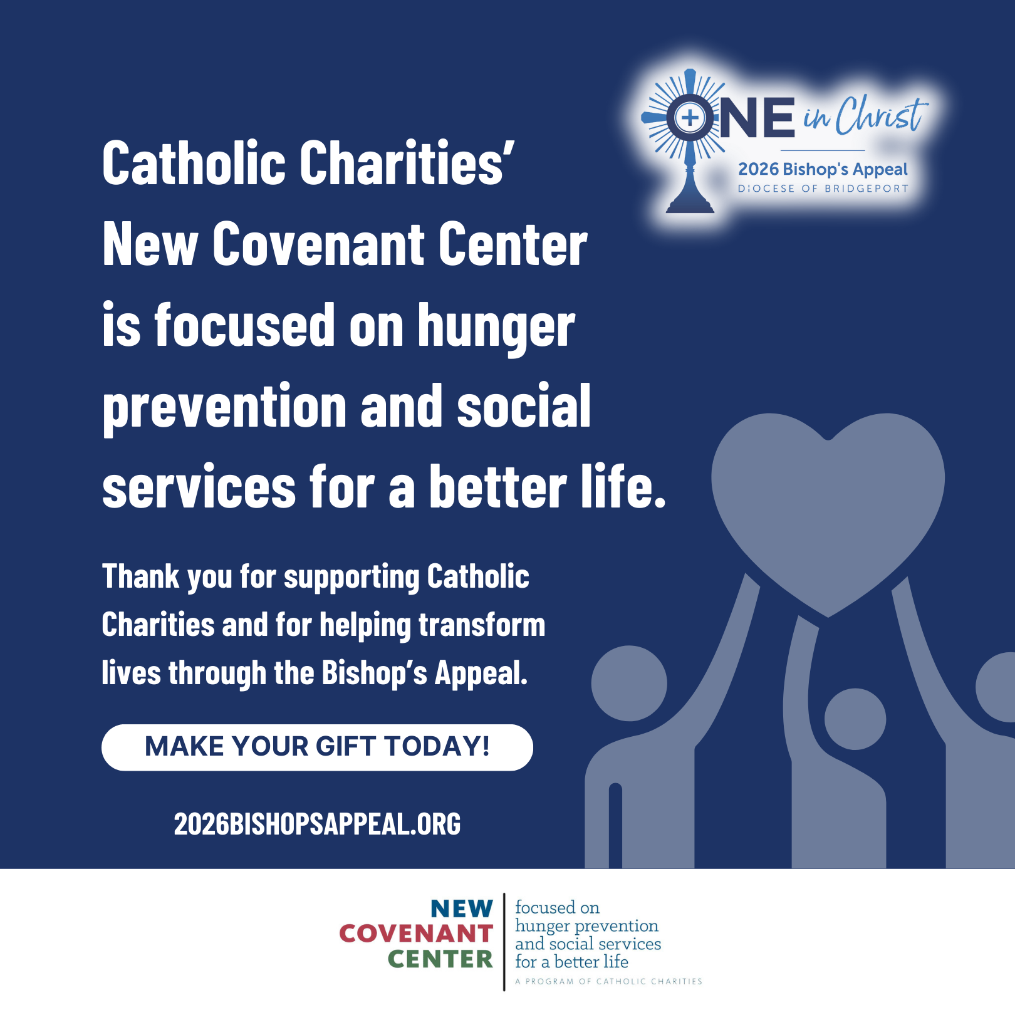
Caption Copy:
Aaron lost his job and his home, leaving him hurt, overwhelmed, and unsure where to turn. But through the support of Catholic Charities’ New Covenant Center in Stamford, he found compassionate accompaniment on his journey forward. ❤️‍🩹🏠
Staff walked with him as he searched for housing, regained focus, and re-entered the job market. Today, he has a new apartment and renewed hope, thanks to their guidance and the programs that support those who are unhoused, seeking employment, and ready to rebuild their lives. 🙌✨
Stories like Aaron’s are made possible through the Bishop’s Appeal. Your generosity helps accompany neighbors in crisis and transform lives every day. 💙🙏
Support Catholic Charities by making your gift to the Bishop’s Appeal today! Visit: 2026BishopsAppeal.org
#2026BishopsAppeal #DioceseofBridgeport #OneinChrist #CatholicCharities
MARCH POSTS
POST #6 TOPIC: | Holy Week | RECOMMENDED POST DATE: | Monday, March 30
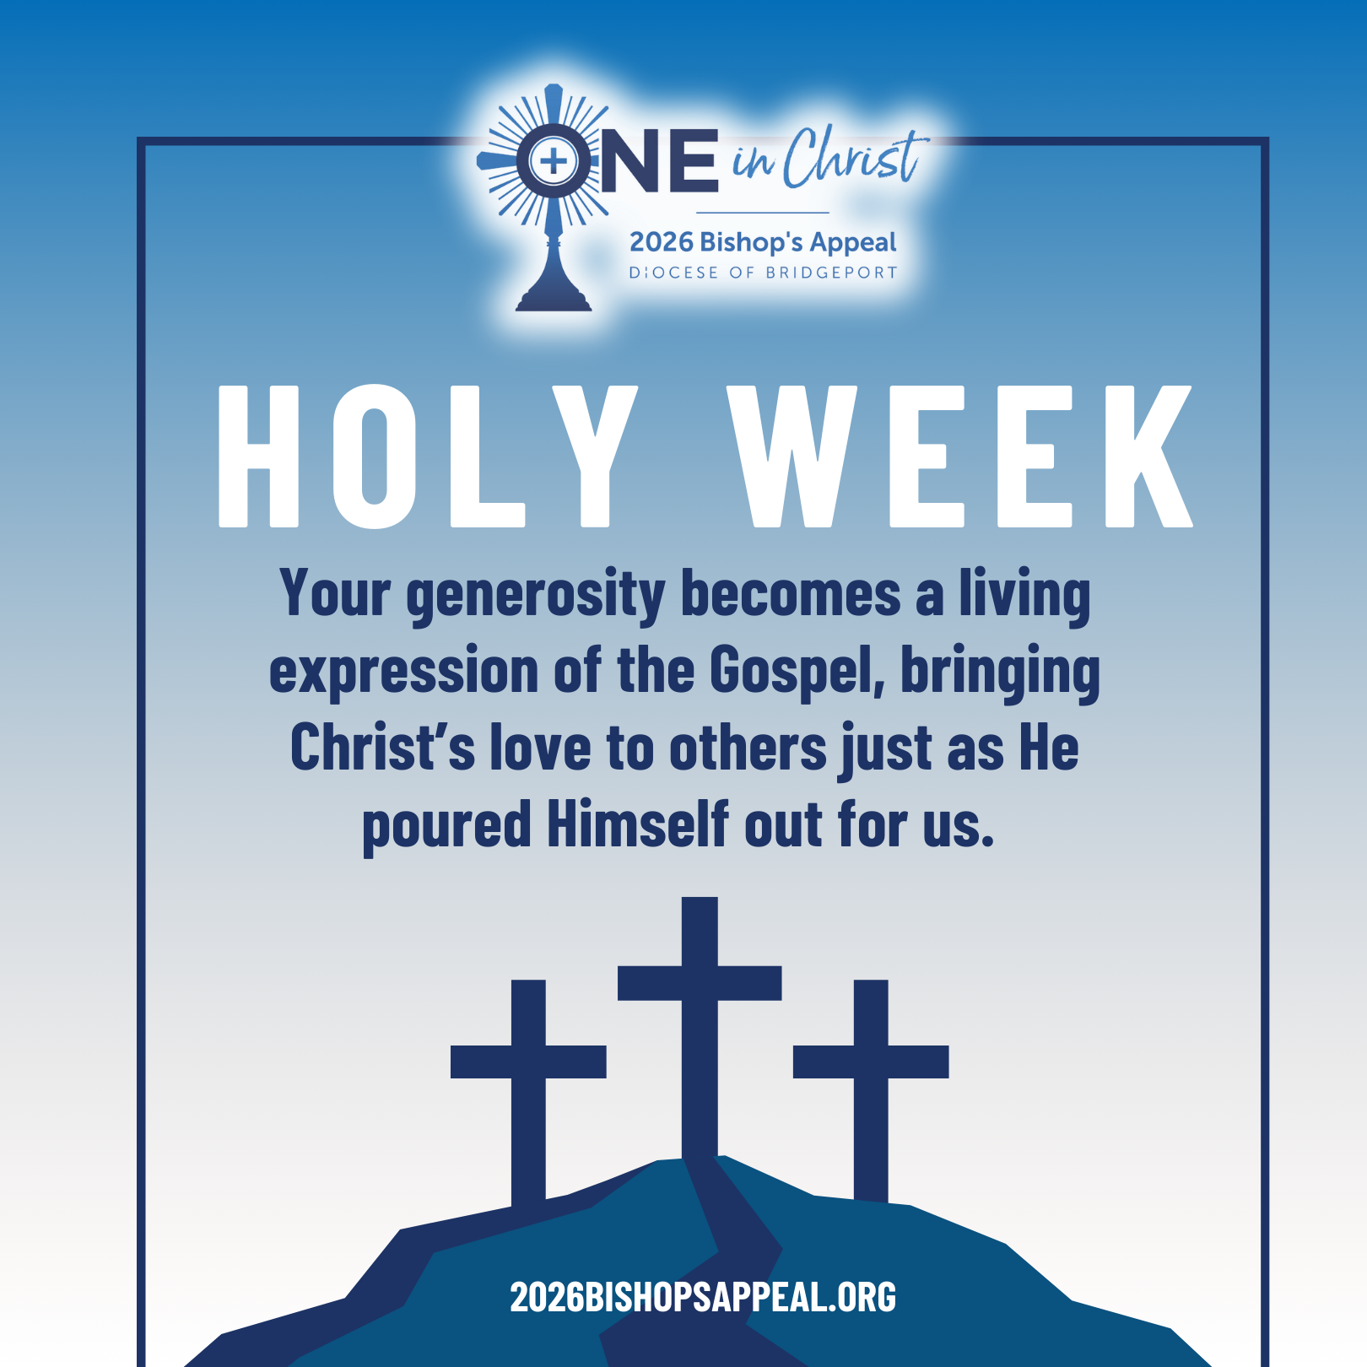
Caption Copy:
As we enter Holy Week, we walk with Christ on the path of His Passion, remembering His profound love and ultimate sacrifice for us. ✝️💛
This sacred week invites us to renew our hearts, deepen our prayer, and recommit ourselves to living as true disciples. Through the 2026 Bishop’s Appeal, our diocesan family continues Christ’s mission, supporting those in need, forming future priests and leaders, caring for the vulnerable, and strengthening Catholic faith and education across Fairfield County.
Your generosity becomes a living expression of the Gospel, bringing Christ’s love to others just as He poured Himself out for us. 🌿
May this Holy Week draw us closer to the Lord and to one another as we walk together as One in Christ. To participate in the Bishop’s Appeal, please visit 2026BishopsAppeal.org
#2026BishopsAppeal #DioceseofBridgeport #OneinChrist #HolyWeek
APRIL POSTS
POST #7 TOPIC: | Ministry Spotlight – Ambassador Program (Cate Gosselin) | RECOMMENDED POST DATE: | Thursday, April 9
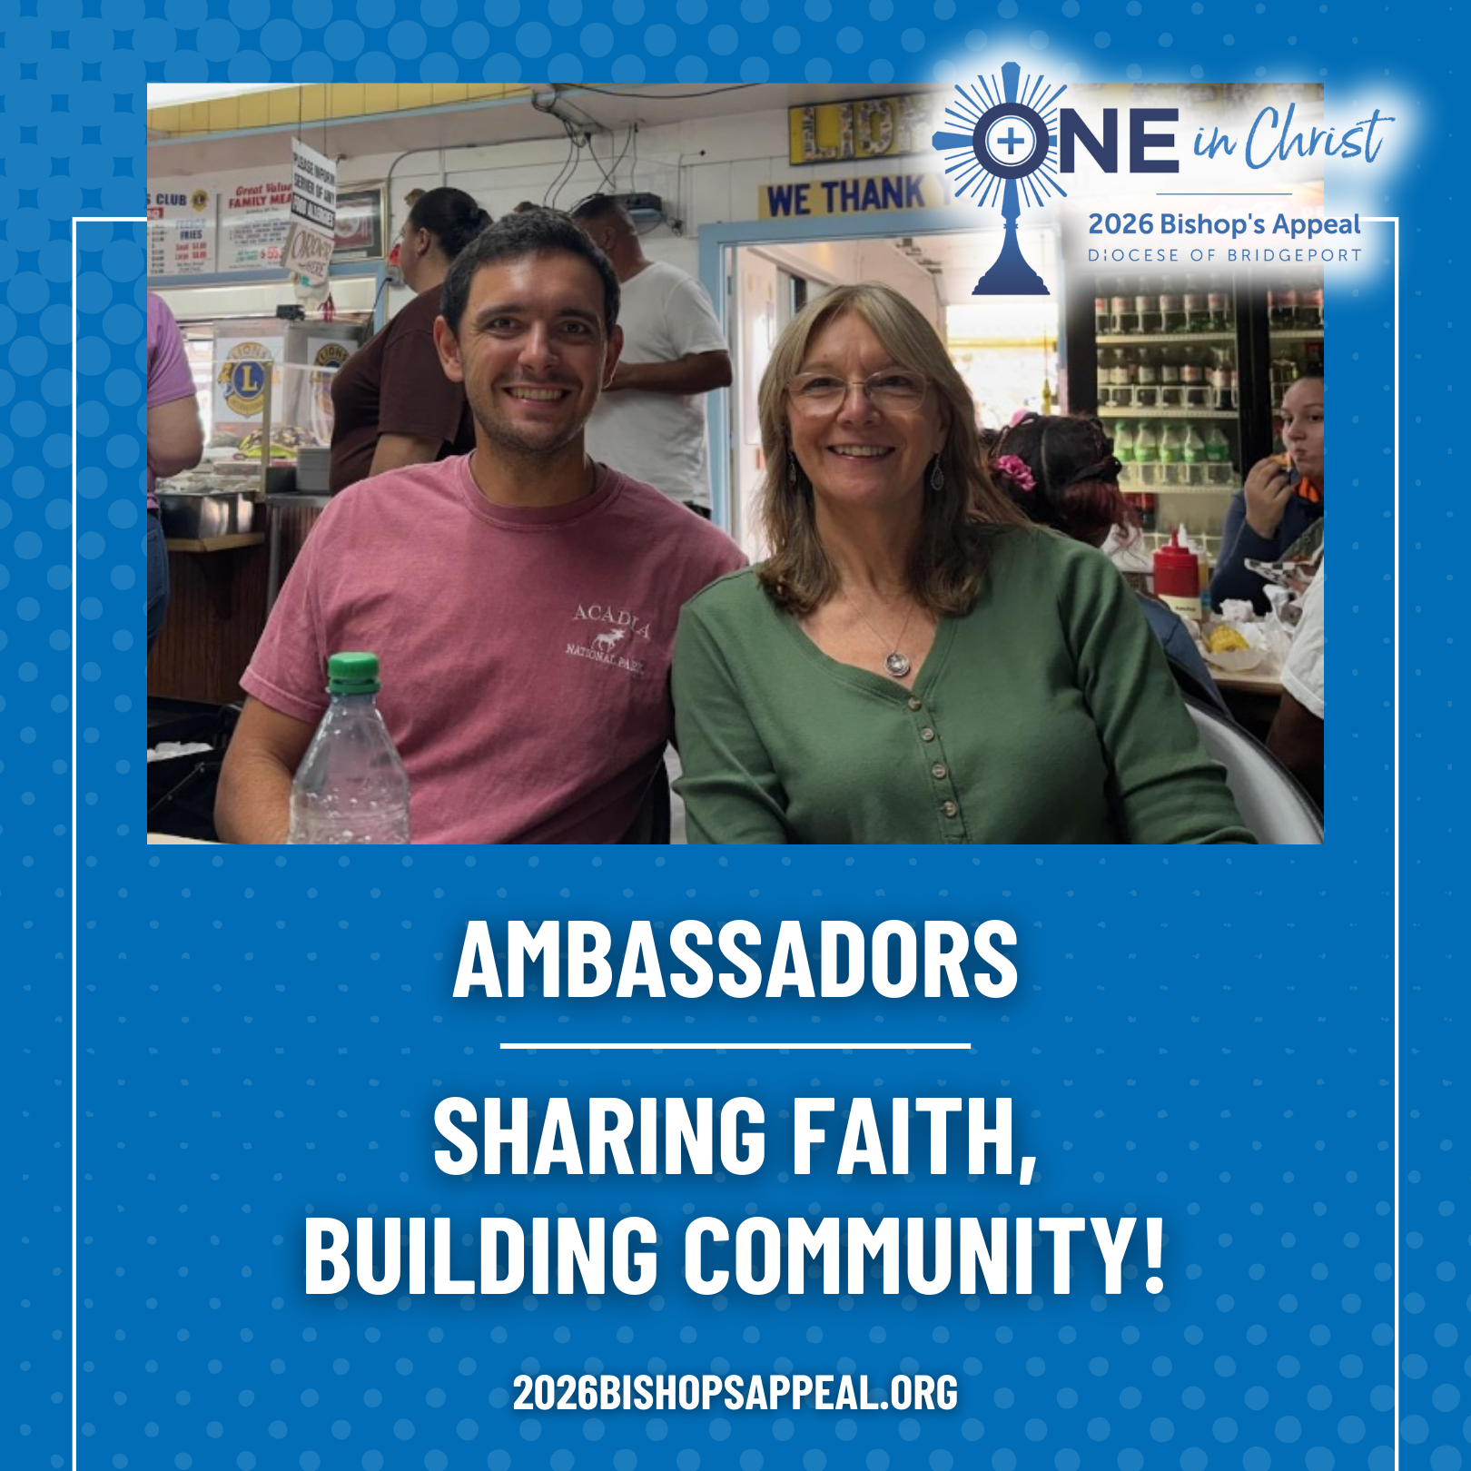
Caption Copy:
Cate Gosselin joined the Ambassadors Program in 2020 to help rebuild parish life and share faith with others. Guided by Monsignor Weiss and supported by God, she now participates in formation, fellowship, and welcoming new parishioners. ✝️💒
Through monthly gatherings, after-Mass coffee and fellowship, and family events, Ambassadors like Cate help others return to their faith while fostering community. “Every day, we have the chance to serve by sharing our faith story or listening to someone else’s,” she says. 🕊️❤️
This ministry embodies the Bishop’s Appeal theme, One in Christ, bringing parishioners together to renew and strengthen the Church.
Help contribute to this program and more, through your gift to the Bishop’s Appeal! Visit: 2026BishopsAppeal.org
#2026BishopsAppeal #DioceseofBridgeport #OneinChrist #Ambassador
APRIL POSTS
POST #8 TOPIC: | Deacon Spotlight – Dcn. David Flynn | RECOMMENDED POST DATE: | Tuesday, April 21
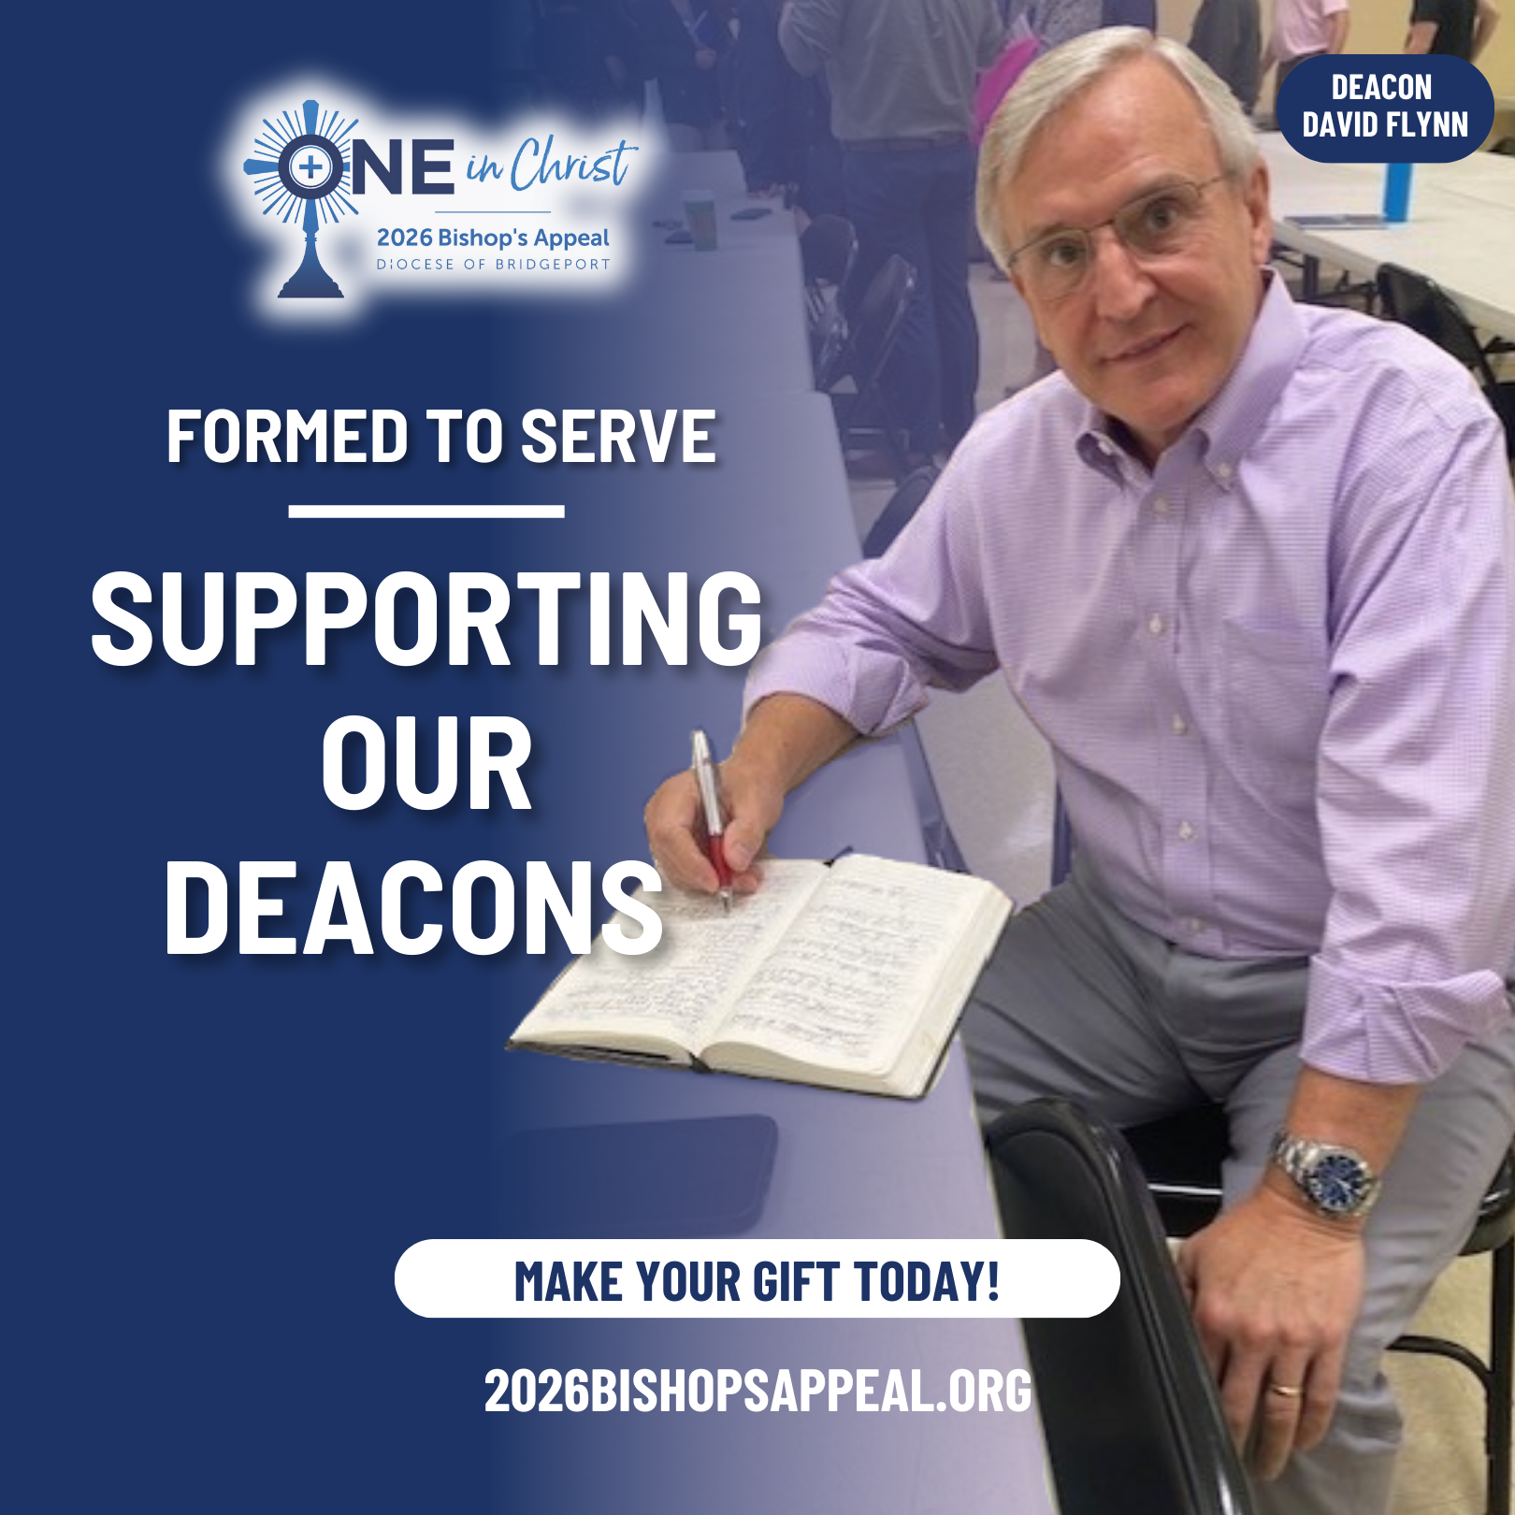
Caption Copy:
For years, Deacon David Flynn quietly sensed a call to the diaconate, until a simple question from his sister became the confirmation he had prayed for. Through five and a half years of formation, his wife, Anita, and trusted spiritual guides walked with him, reminding him that “to preach well, you have to pray.”
His ministry has deepened his relationship with Christ and strengthened his family’s faith, as he accompanies parishioners, OCIA candidates, and all who seek a deeper encounter with God. Formation programs, retreats, spiritual direction, and diocesan resources have continued to nourish his vocation and prepare him to serve as a witness of truth, healing, and unity.
The Bishop’s Appeal supports the formation and ongoing training of deacons like Deacon Flynn, helping them serve the Church’s mission of renewal and bring us together as One in Christ.
Make your gift to the Bishop’s Appeal today! Visit: 2026BishopsAppeal.org
#2026BishopsAppeal #DioceseofBridgeport #OneinChrist #Diaconate

MAY POSTS
POST #9 TOPIC: | Month of Mary | RECOMMENDED POST DATE: | Monday, May 4
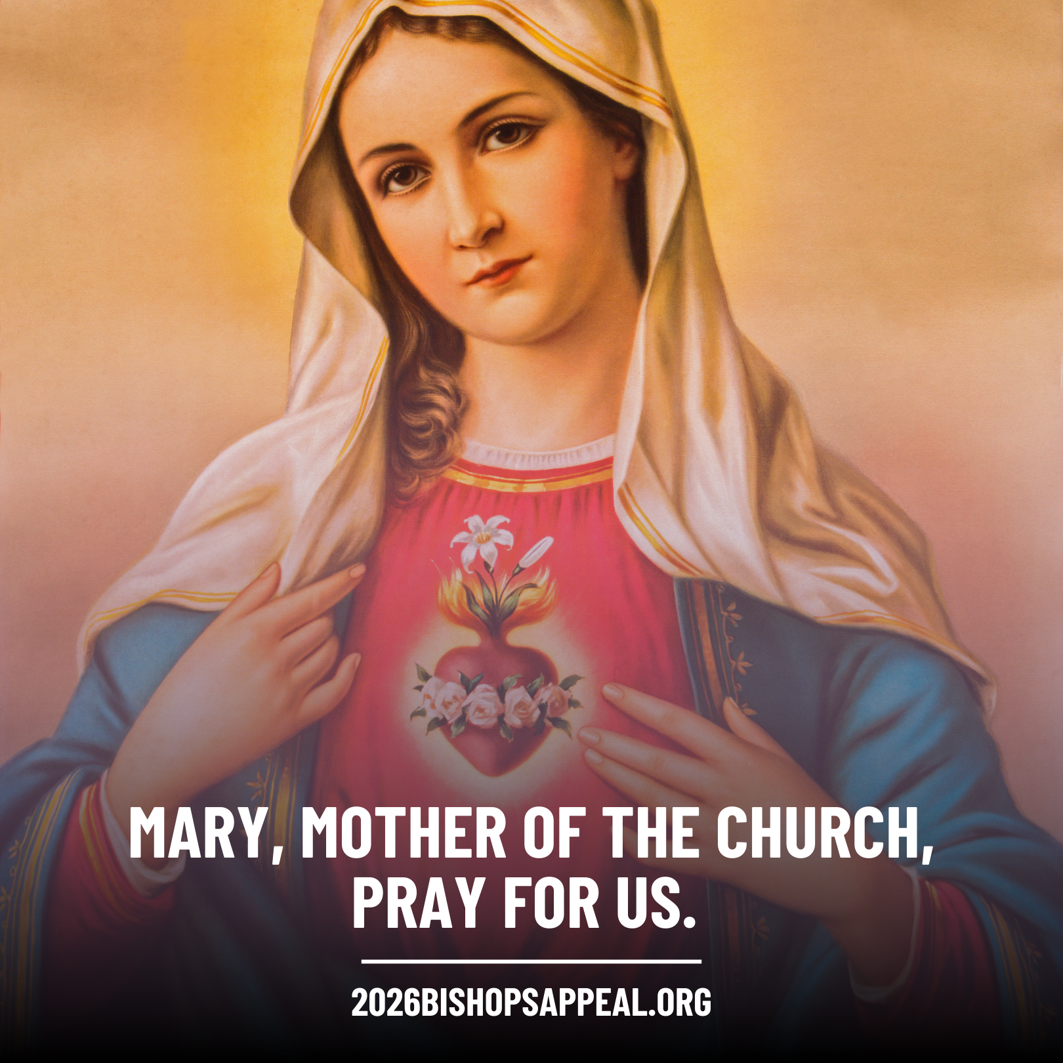
Caption Copy:
During the month of May, we turn our hearts to Mary, our Mother, who faithfully said “yes” to God and continues to guide us closer to her Son. ✝️💙
As we honor Mary’s example of trust, courage, and discipleship, we also pray for those discerning their own “yes” to God’s call, especially our seminarians and all discerning vocations. 🌿
Through the 2026 Bishop’s Appeal, our diocesan family supports the formation of future priests, the nurturing of faith in our parishes and schools, and ministries that bring Christ’s love to those most in need. Your generosity helps others follow Mary’s example of openness to God’s plan.
Mary, Mother of the Church, pray for us. 🙏🌹
💙 Make your gift to the Bishop’s Appeal today! Visit: 2026BishopsAppeal.org
#2026BishopsAppeal #DioceseofBridgeport #OneinChrist #MonthofMary
MAY POSTS
POST #10 TOPIC: | Ministry Spotlight – St. Luke Guild (Tom Walsh) | RECOMMENDED POST DATE: | Thursday, May 14

Caption Copy:
As a chaplain at Yale New Haven Hospital, Tom Walsh witnessed firsthand the dedication and compassion of healthcare providers. 🏥💙 To extend his ministry and support those who care for others, he joined the St. Luke Guild, a community dedicated to forming and spiritually supporting healthcare professionals across the Diocese. ✝️🙏
Through the Guild, Tom participates in prayerful encounters, book discussions 📚, and acts of mercy such as food drives 🍲. These experiences foster fellowship among members and provide spiritual nourishment to those on the frontlines of care.
Tom says, “The Lord has transformed my life as a member of the Guild by showing me St. Paul’s teaching, how all of us, though many, are one body in Christ.” (Romans 12:4-5) 🌟
The Bishop’s Appeal helps support ministries like the St. Luke Guild, strengthening the Church’s mission by forming and accompanying those who serve others. 💛
Make your gift to the Bishop’s Appeal today! Visit: 2026BishopsAppeal.org
#2026BishopsAppeal #DioceseofBridgeport #OneinChrist #TheGuild
JUNE POSTS
POST #11 TOPIC: | Pastoral Accompaniment: Pastoral Companions | RECOMMENDED POST DATE: | Thursday, April 9
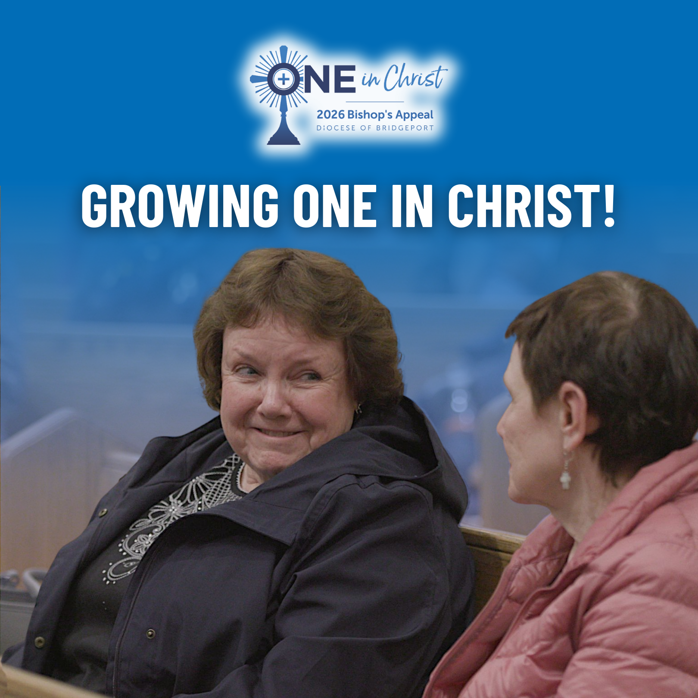
Caption Copy:
Across the Diocese of Bridgeport, many face loneliness, isolation, and spiritual disconnection. 💛 Through The One, Pastoral Companions walk with people through home visits, prayer, and one-on-one spiritual friendship.
They visit individuals in homes, nursing homes, and hospitals — praying together, sharing Scripture, bringing Communion, and even offering reflections from Mass so no one feels disconnected. 📖✨ Weekly bulletins, music from Mass, and meals from parish groups like Caring Cooks help people stay connected to their parish family. 🍲🎶
Whether short-term during illness or in the later years of life, these visits remind people they are not alone. 💞 The Bishop’s Appeal makes this care possible as we grow One in Christ.
Make your gift to the Bishop’s Appeal today! Visit: 2026BishopsAppeal.org
#2026BishopsAppeal #DioceseofBridgeport #OneinChrist #PastoralAccompaniment

JUNE POSTS
POST #12 TOPIC: | Father’s Day/ Retired Priests (Msgr. Edward Surwilo & Fr. James Grosso) | RECOMMENDED POST DATE: | Thursday, June 18
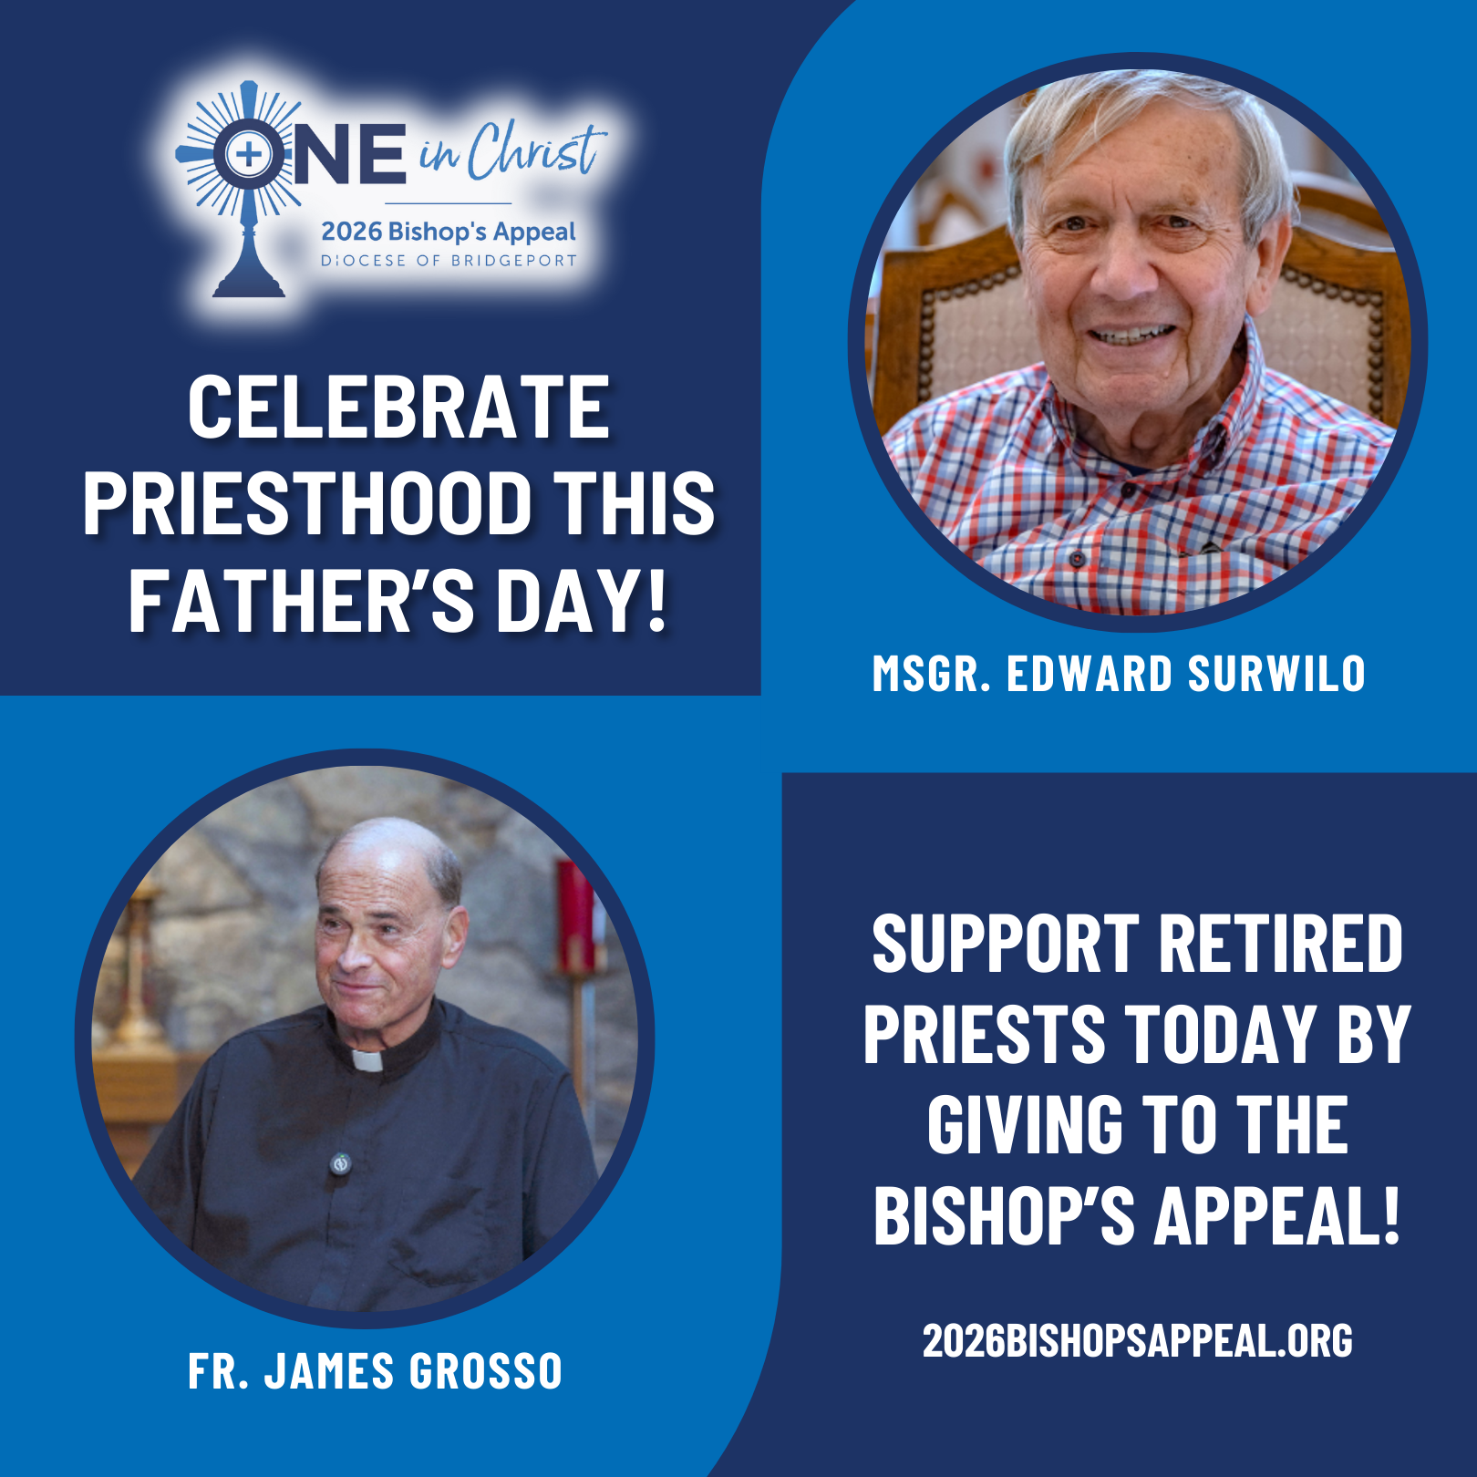
Caption Copy:
This Father’s Day, we celebrate the gift of priesthood and the faithful service of priests who guide, comfort, and inspire our communities. ✝️
One of our retired priests, Msgr. Edward Surwilo, has served the Diocese for 61 years, offering presence and care to countless families, from baptisms to funerals, and still serves in retirement, celebrating Mass, funerals, and supporting parish life. 🙏💒
Another priest of ours, Fr. James Grosso, now retired, pastored St. Leo Parish for decades and cherishes the joy of ministry: celebrating sacraments, supporting families, and sharing in the life of the Church. Even in retirement, he continues to bring Christ to the faithful. ✨💖
Lives like theirs remind us that priesthood is a vocation of love, service, and presence. The Bishop’s Appeal supports retired priests like Msgr. Surwilo, Fr. Grosso, and many others, while also helping to form the next generation of vocations, ensuring that communities continue to experience Christ’s love through pastoral care.🌟 Support retired priests today by giving to the Bishop’s Appeal! Visit: 2026BishopsAppeal.org
#2026BishopsAppeal #DioceseofBridgeport #OneinChrist #RetiredPriests
JULY POSTS
POST #13 TOPIC: | Vocations | RECOMMENDED POST DATE: | Tuesday, July 7
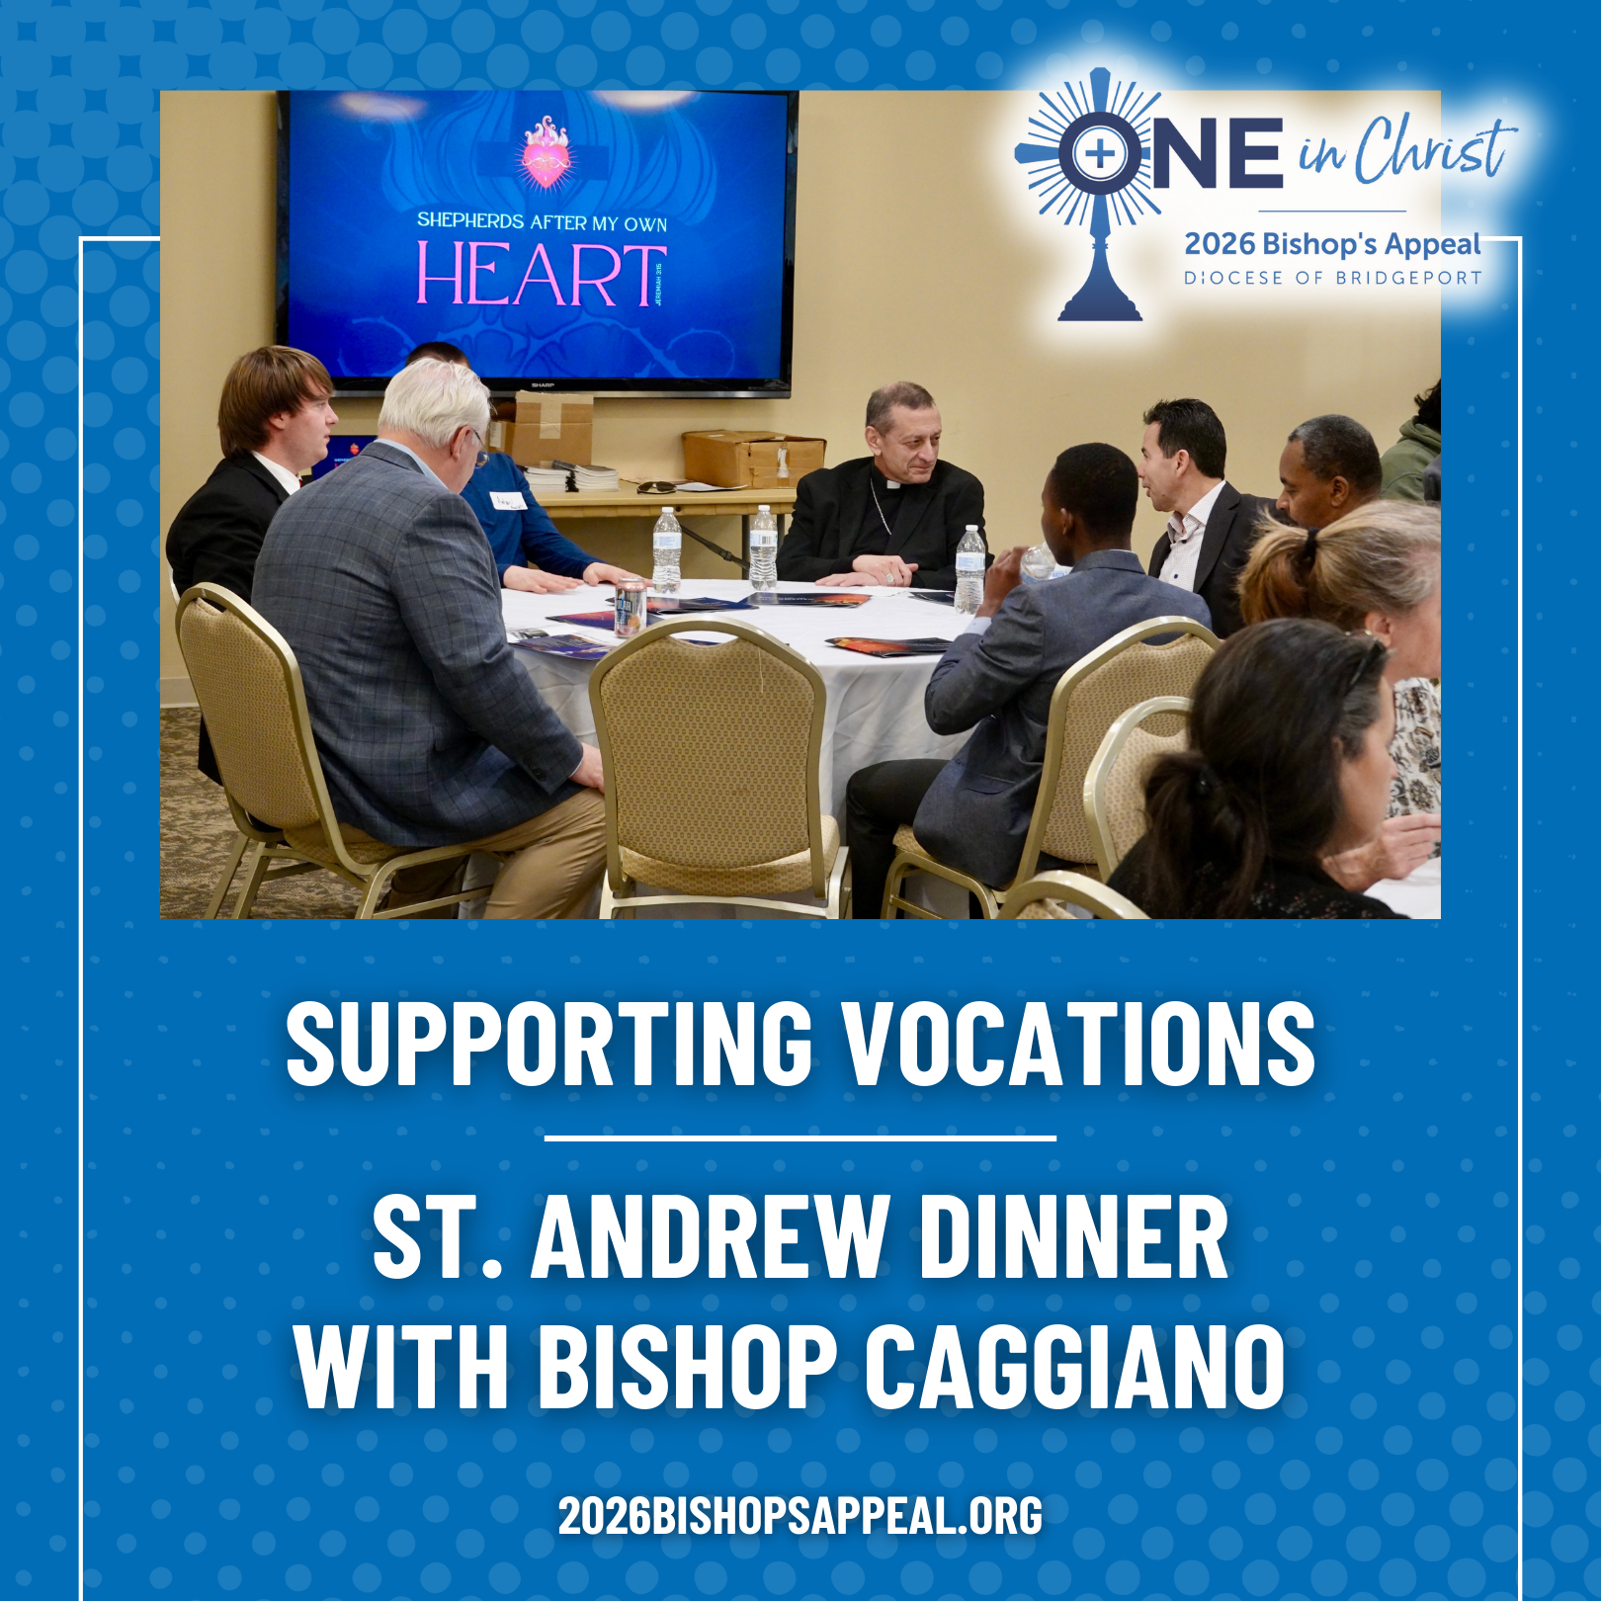
Caption Copy:
This past fall, a diverse group of young men ranging from teachers, students, engineers, a zoo staffer, a woodworker, a recent convert from Hinduism, and more, gathered with Bishop Frank J. Caggiano for a powerful St. Andrew Dinner. 🙏✨
Together they prayed, shared a meal, and spoke openly about discernment and the possibility of priesthood. Bishop Caggiano encouraged them to rediscover the gift of silence and listen deeply for the Lord’s voice: “God has already chosen the better path—our task is to hear it.”
Your generosity to the Bishop’s Appeal makes moments like this possible by supporting seminarians, vocation programs, and the ongoing work of forming future priests. 💒🔥
Support future vocations today! Visit: 2026BishopsAppeal.org
#2026BishopsAppeal #DioceseofBridgeport #OneinChrist #Vocations

JULY POSTS
POST #14 TOPIC: | Ministry Spotlight – St. Jerome Center | RECOMMENDED POST DATE: | Thursday, July 23
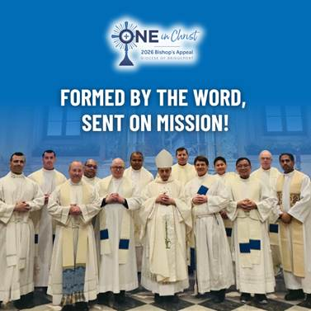
Caption Copy:
Two years into The One, the Diocese is witnessing powerful renewal, most clearly through the new St. Jerome Center for Preaching and Biblical Studies. ✨ Rooted in the belief that strong preaching leads to conversion, the Center is forming clergy and laity to engage the Word of God more deeply and live as missionary disciples. 📖🔥
By supporting deacons at national preaching and biblical conferences, the Center is expanding opportunities for spiritual growth and strengthening the Church’s witness. 🙏✨ Already, its work is shaping a culture of encounter, discipleship, and evangelization across the Diocese. 🌟
The Bishop’s Appeal helps make this transformation possible, advancing The One’s mission to bring every believer closer to Christ through truth, beauty, and goodness. ✝️💛
Make your gift to the Bishop’s Appeal today! Visit: 2026BishopsAppeal.org
#2026BishopsAppeal #DioceseofBridgeport #OneinChrist #MissionaryDisciples

AUGUST POSTS
POST #15 TOPIC: | Young Adult Ministry Spotlight – Thomas Angiolillo | RECOMMENDED POST DATE: | Tuesday, August 4
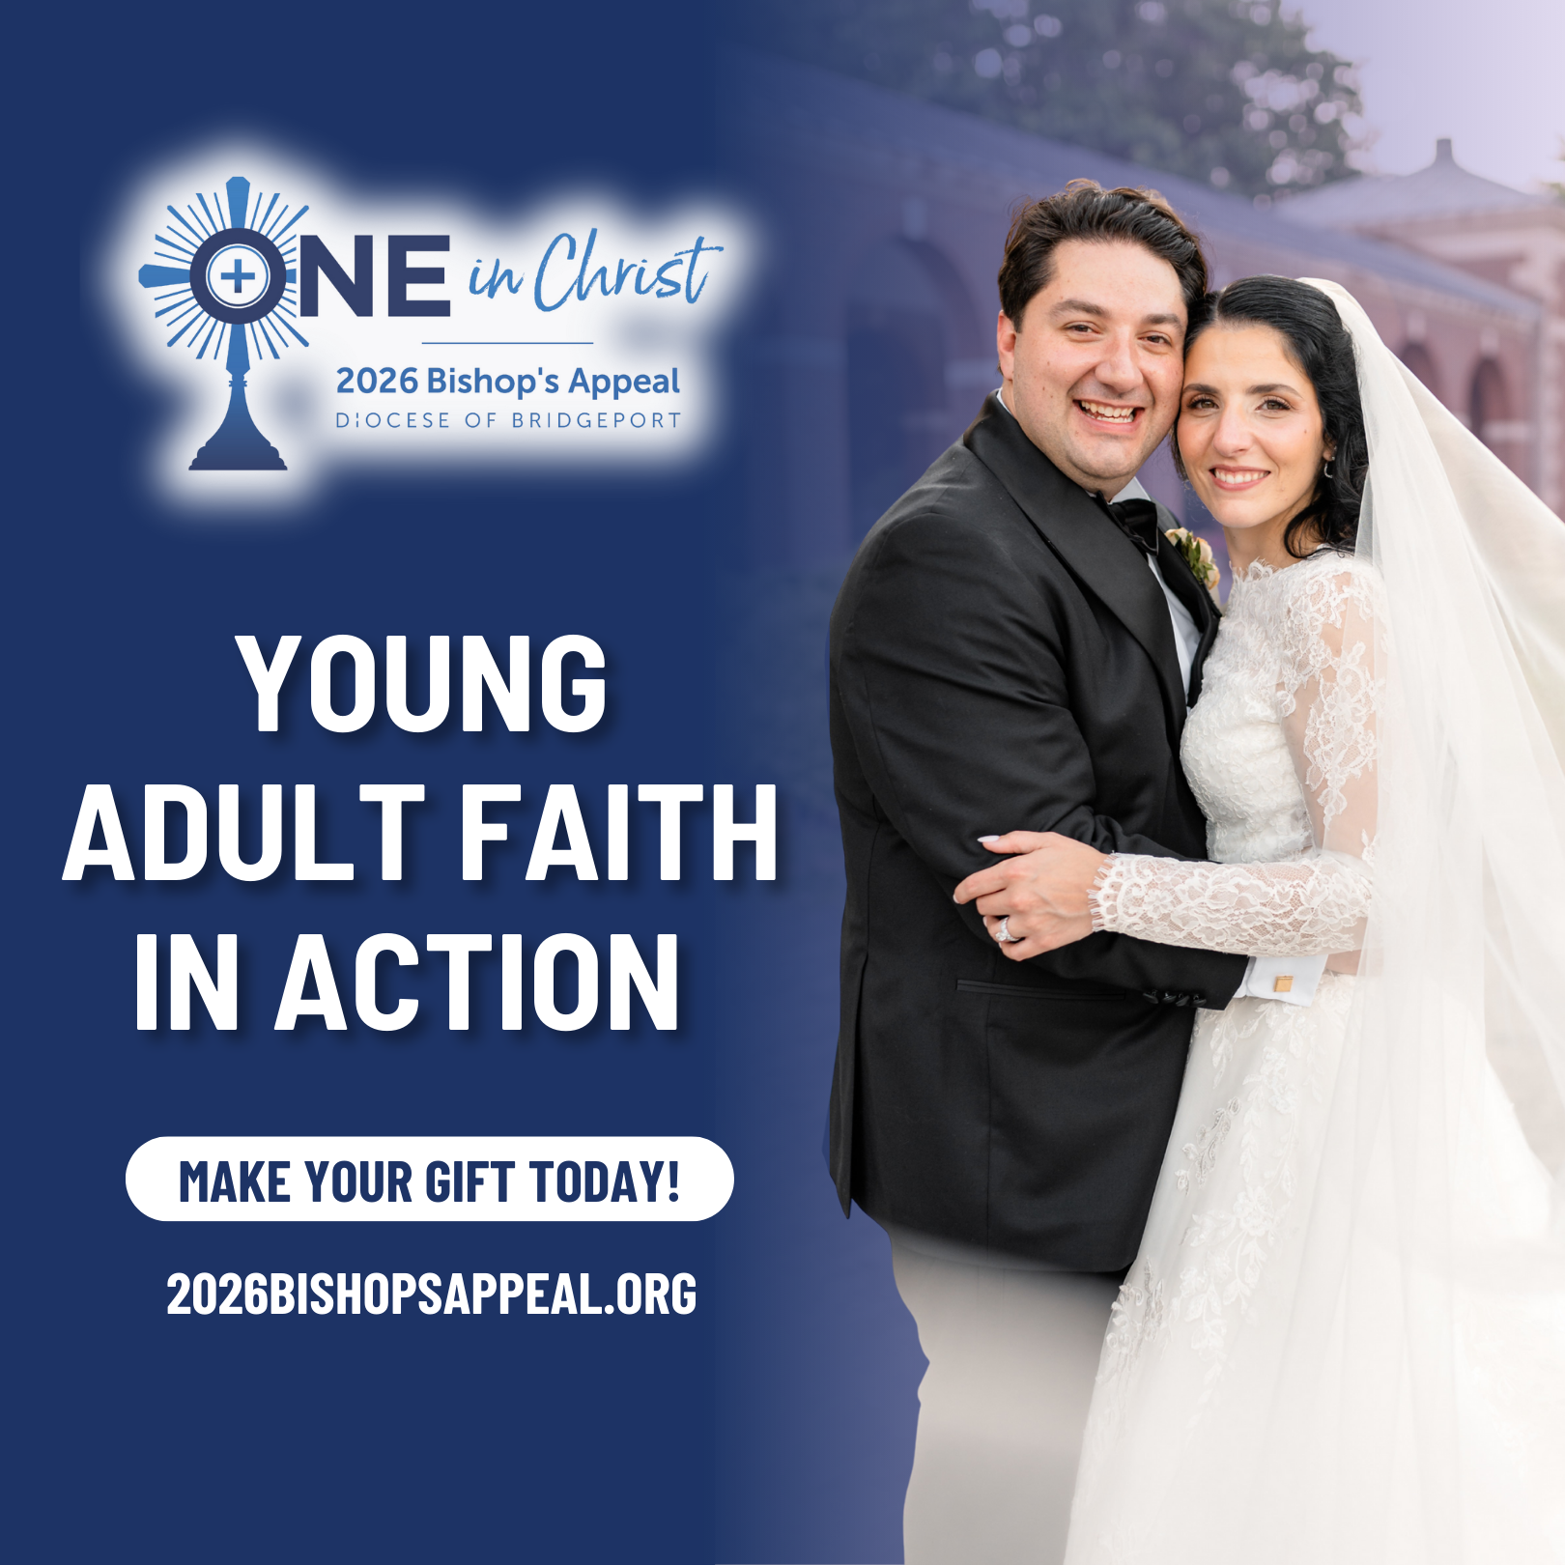
Caption Copy:
Thomas Angiolillo first discovered the Stamford Young Adult community at a men’s conference, where a C4C booth caught his attention. With encouragement from faith-filled friends, he began attending regularly and found a place where young adults grow spiritually together through prayer, Bible study, service, and authentic fellowship. 🙏📖💛
Now he helps lead the monthly Young Adult Mass at Holy Name of Jesus, an evening of adoration, confession, Mass, and fellowship that continues to bring young Catholics together in powerful ways. The ministry has strengthened his faith, deepened his purpose, and transformed his relationship with Christ through community and service. ✝️🔥
The Bishop’s Appeal helps make ministries like this possible, supporting young adult outreach that renews the Church, builds unity, and forms the next generation of Catholic leaders. 🌟
Make your gift to the Bishop’s Appeal today! Visit: 2026BishopsAppeal.org
#2026BishopsAppeal #DioceseofBridgeport #OneinChrist #YoungAdultMinistry
AUGUST POSTS
POST #16 TOPIC: | Ministry Spotlight- Peace in the Storm | RECOMMENDED POST DATE: | Thursday, August 20
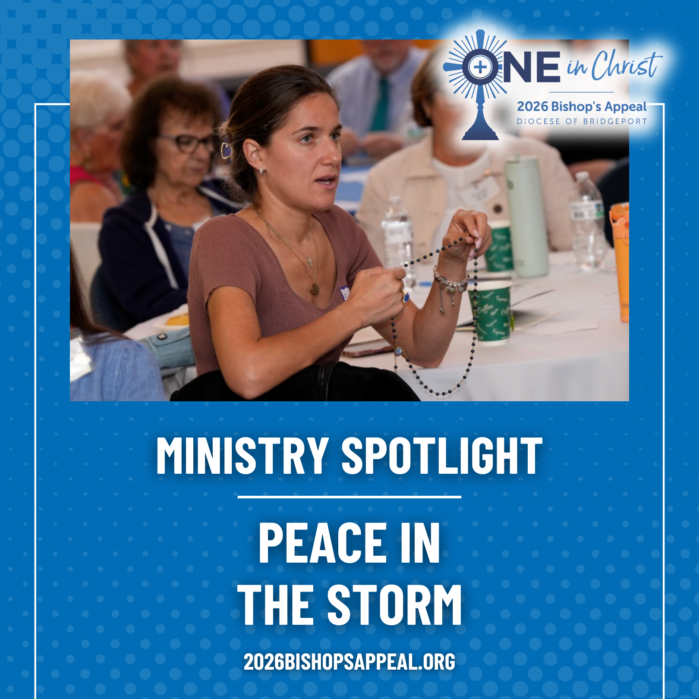
Caption Copy:
During the pandemic, Pat Calanca and Fr. David Roman launched Peace in the Storm at St. Aloysius in New Canaan, a spiritual support group for parishioners facing health challenges and for caregivers seeking strength. Using the “Peace in the Storm” book as their guide, the group meets monthly for prayer, discussion, and faith-filled fellowship.
This lay-led ministry requires no special training and has become a powerful expression of accompaniment, the heart of the Bishop’s Appeal, One in Christ.
Thanks to the Bishop’s Appeal, ministries like Peace in the Storm continue to grow, offering hope, community, and spiritual support to those who need it most.
Make your gift to the Bishop’s Appeal today! Visit: 2026BishopsAppeal.org
#2026BishopsAppeal #DioceseofBridgeport #OneinChrist #PeaceintheStorm

SEPTEMBER POSTS
POST #17 TOPIC: | Ministry Spotlight – Pastoral Companions Program (Lisa Sheehan) | RECOMMENDED POST DATE: | Wednesday, September 9
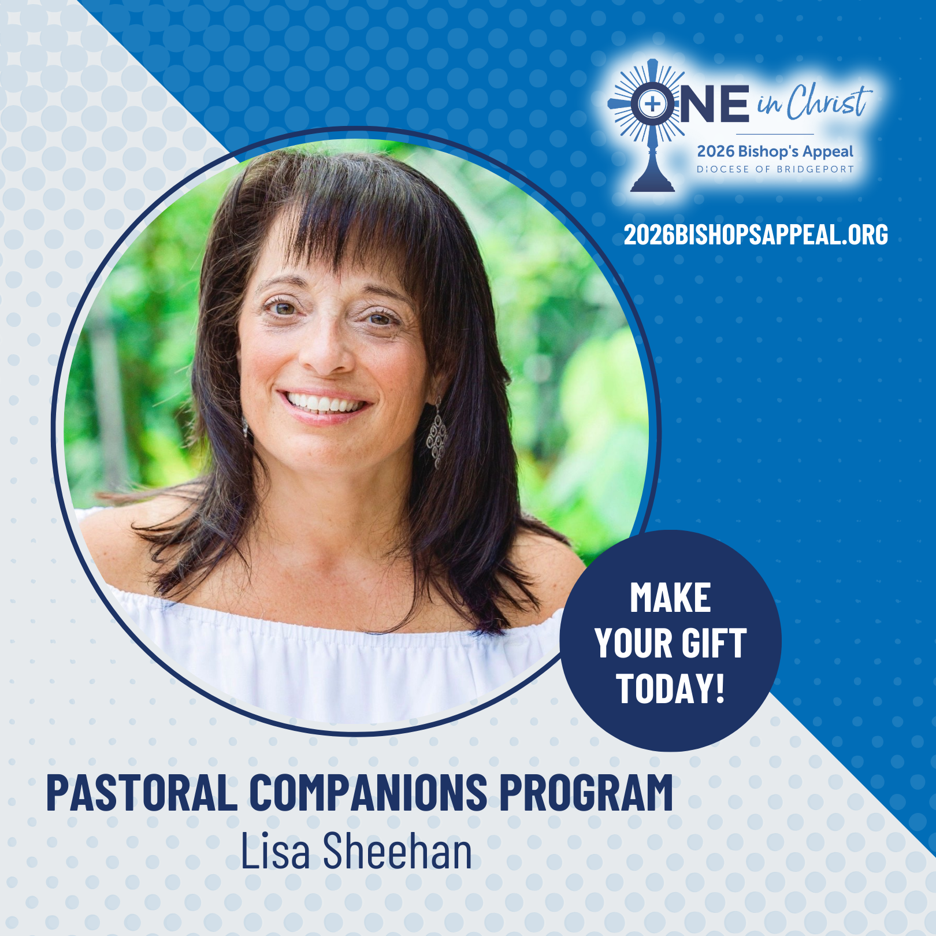
Caption Copy:
Lisa Sheehan is one of many who serves in the Pastoral Companions program, visiting parishioners in their homes, nursing facilities, and hospitals. 🏡💒
Through prayer, Scripture, and sharing the Eucharist, these companions bring comfort, connection, and community to those who are homebound or in need. ✝️ From celebrating birthdays to accompanying someone in their final days, each visit is a ministry of love and faith in action. 💛
The program not only strengthens the faith of those visited but also enriches the lives of the companions themselves, deepening their relationship with Christ and their parish community. 🙏
Acts of service like these are the heart of The One initiative, reminding us of Matthew 25:40: “Whatever you did for the least of my brothers and sisters, you did for me.” 🌟
The Bishop’s Appeal helps make ministries like this possible. 💙 Make a gift today and support the ongoing pastoral renewal in our Diocese! Visit: 2026BishopsAppeal.org
#2026BishopsAppeal #DioceseofBridgeport #OneinChrist #PastoralCompanions
SEPTEMBER POSTS
POST #18 TOPIC: | Youth Ministry Spotlight – Thomas Shullman | RECOMMENDED POST DATE: | Thursday, September 24
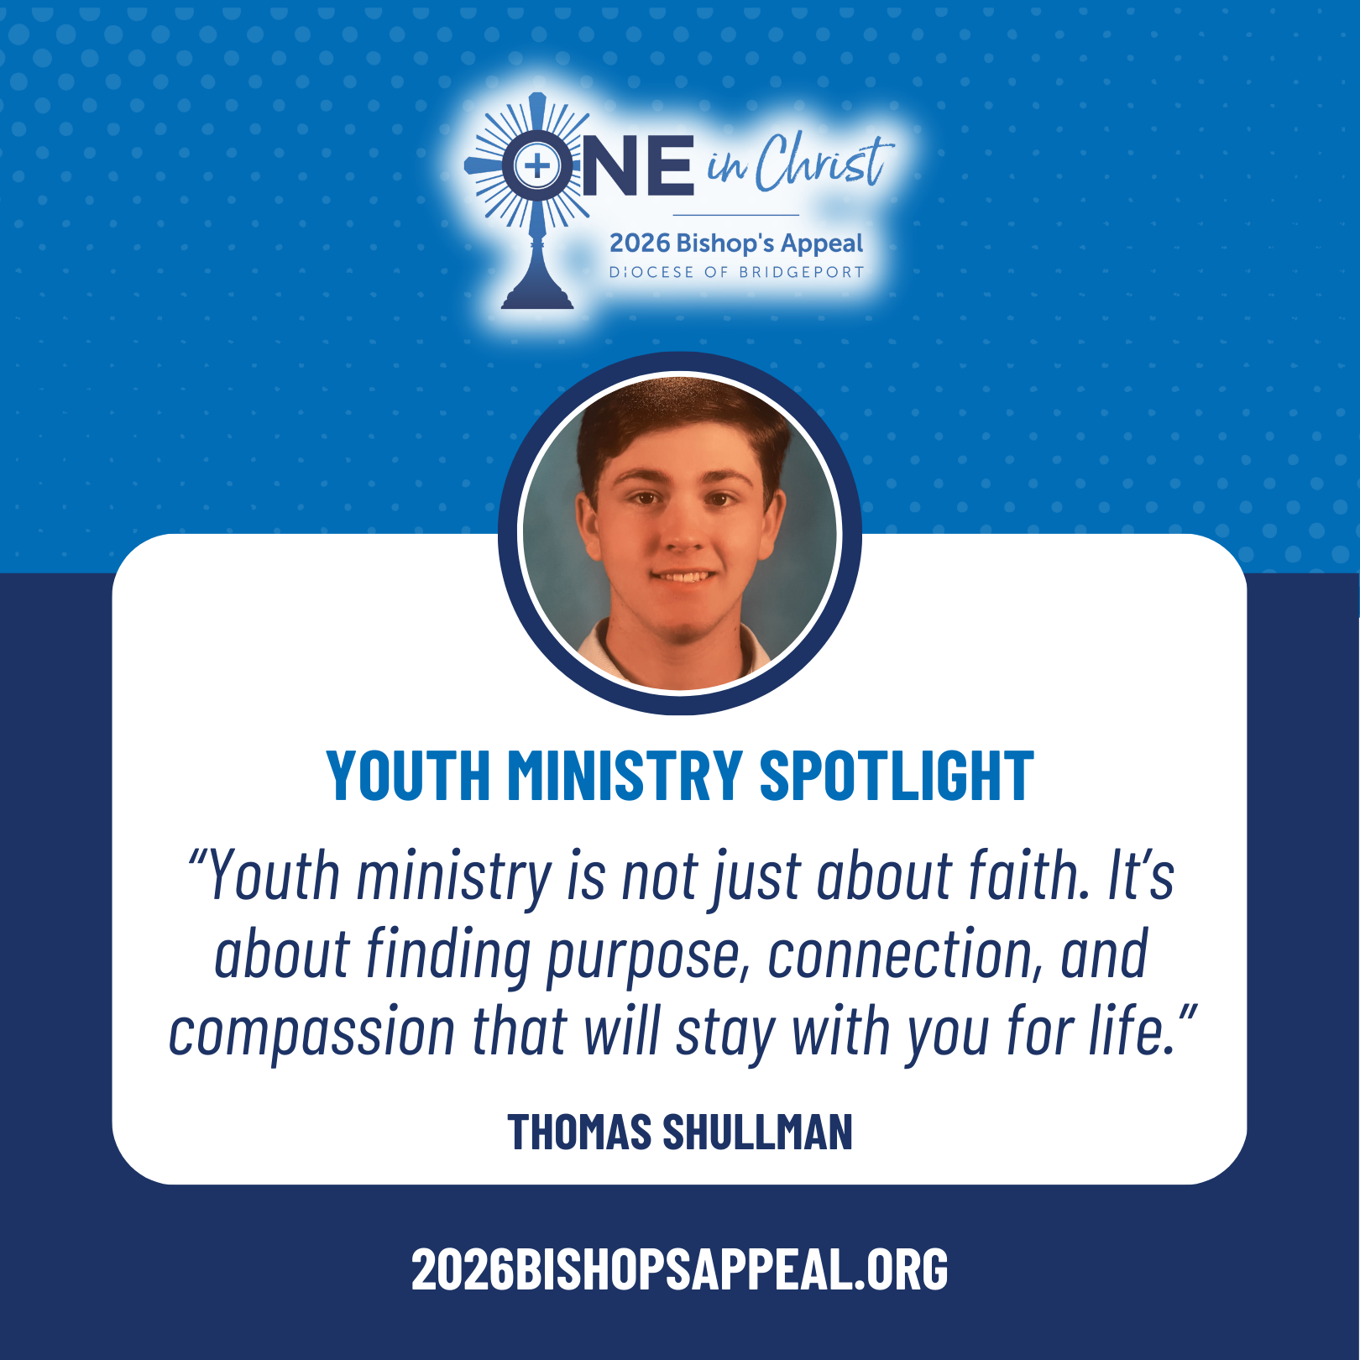
Caption Copy:
Thomas Shullman and his family have experienced firsthand the transformative power of St. Aloysius’ Youth Ministry. From Emmaus retreats 🙏💛 to mission trips to Kentucky 🚍🌟 and breakfast runs in NYC 🥪🏙️, youth ministry offers teens opportunities to grow in faith, serve others, and encounter Christ in everyday life.
Thomas says, “Youth ministry is not just about faith. It’s about finding purpose, connection, and compassion that will stay with you for life.” 💖
Parents also play an important role, volunteering in events like Christmas Stars, Midnight Run, and Breakthru Options, creating fellowship among families and strengthening the parish community. 👨‍👩‍👧‍👦
The Bishop’s Appeal helps support programs like St. Aloysius’ Youth Ministry, forming the next generation of Catholic leaders and fostering discipleship through service and community. 💛
Make your gift to the Bishop’s Appeal today! Visit: 2026BishopsAppeal.org
#2026BishopsAppeal #DioceseofBridgeport #OneinChrist #YouthMinistry
OCTOBER POSTS
POST #19 TOPIC: | Diaconate Spotlight- Andres Grajales | RECOMMENDED POST DATE: | Tuesday, October 6
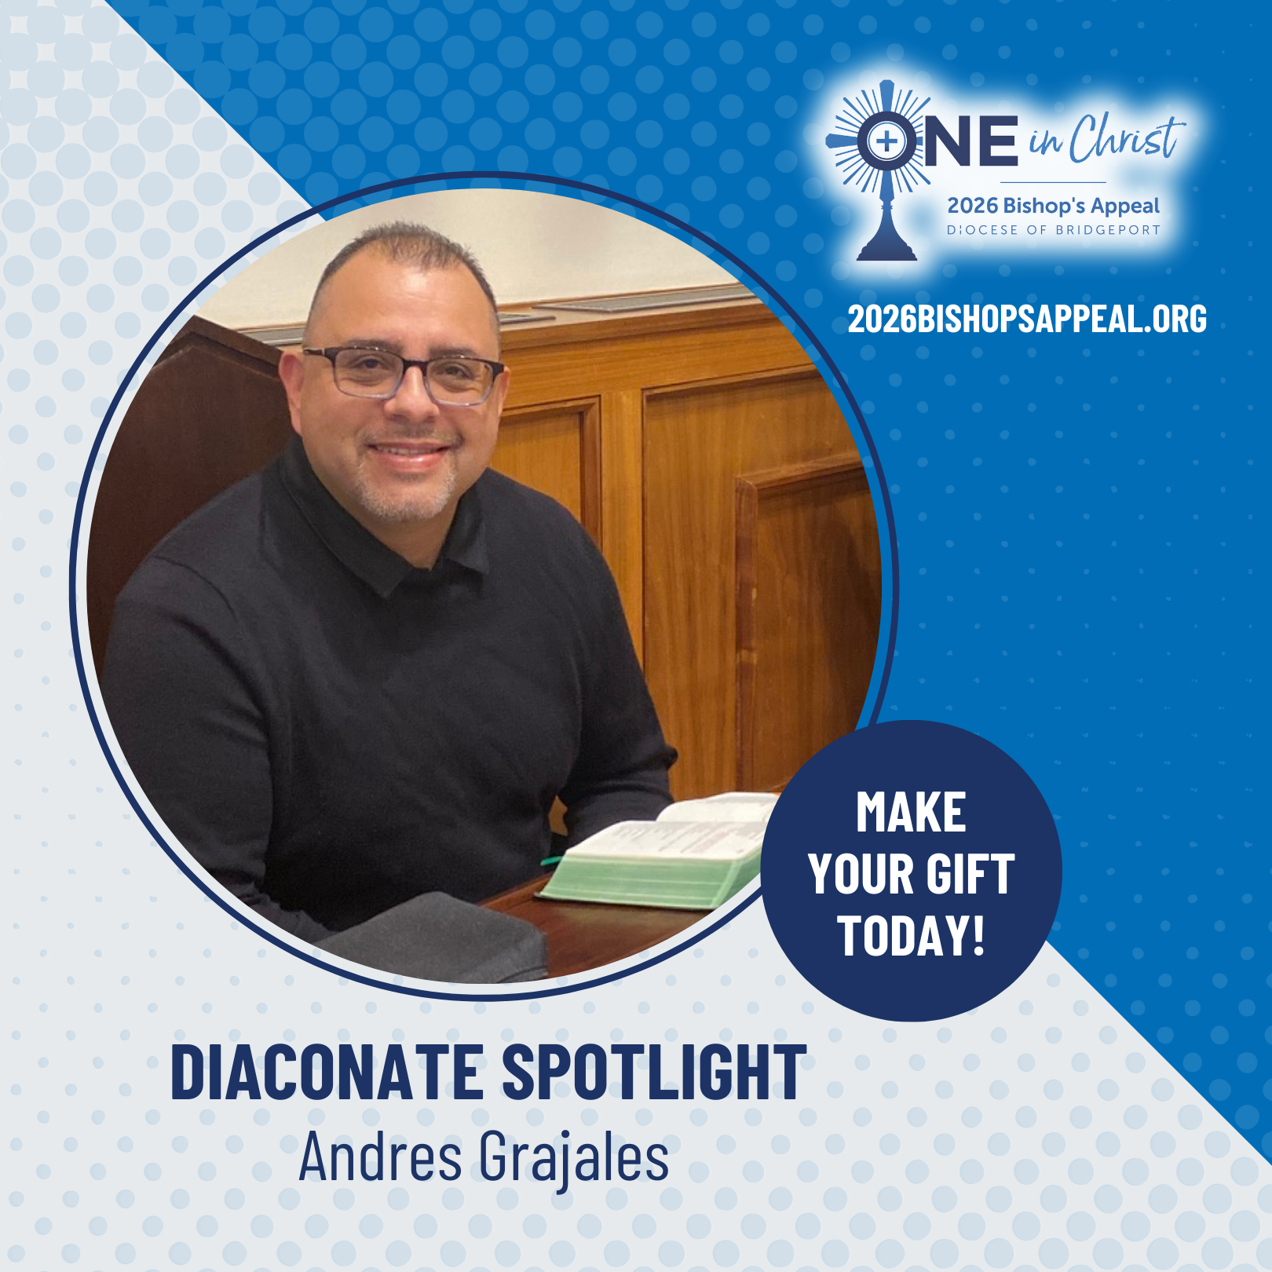
Caption Copy:
For Andres Grajales, the call to the diaconate came gently but clearly, through three different priests, each encouraging him to discern God’s invitation. With the support of his family, the Charismatic Renewal community, and his pastor, he entered formation and discovered one of the most fulfilling experiences of his life. 🙏
Andres hopes, God willing, to serve as a deacon who reflects Christ’s light to all, both within the Church and to those yet to encounter Him, strengthening renewal and unity as One in Christ.
The Bishop’s Appeal makes diaconate formation possible, supporting the education, spiritual guidance, and pastoral training of future deacons like Andres. 🌟
Learn more and make your gift today by visiting: 2026BishopsAppeal.org
#2026BishopsAppeal #DioceseofBridgeport #OneinChrist #Diaconate

OCTOBER POSTS
POST #20 TOPIC: | Apologetics Spotlight- Suan Sonna | RECOMMENDED POST DATE: | Wednesday, October 21
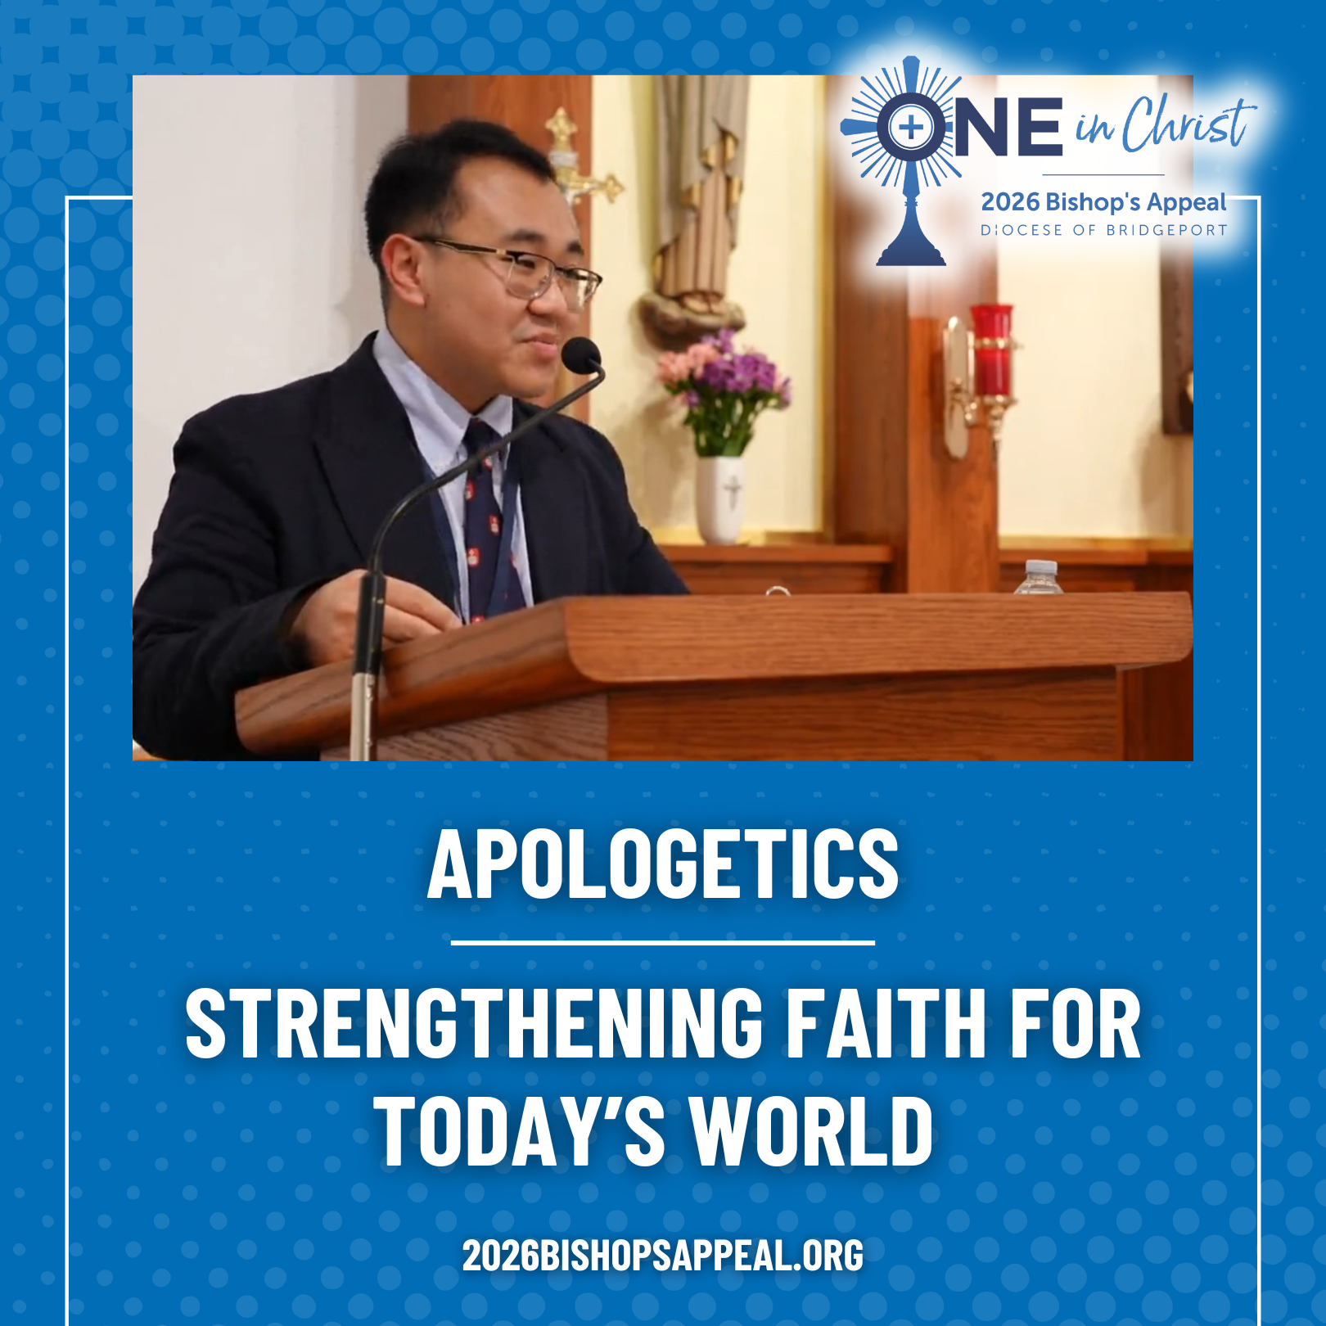
Caption Copy:
In a world full of questions, Catholics are called to know their faith, live it deeply, and share it with clarity, confidence, and charity.
That’s why the Diocese of Bridgeport is excited for the work of Suan Sonna, Director of Apologetics, whose mission is to:
✨ Teach what we believe, why we believe it, and how to share it with grace
✨ Create opportunities to encounter Christ, the One Who is Truth
✨ Accompany people through their questions with presence and care
Suan’s vision of apologetics goes beyond “defending the faith.” It’s about intellectual formation rooted in F.I.R.E. — Fidelity, Integrity, Rigor, and Empathy, helping Catholics grow closer to Christ and confidently engage today’s culture.
Through conversations, retreats, testimony nights, mentorship, and youth initiatives, this office is helping build a thoughtful, faithful Church for the future. 💒
All of this is supported by the Bishop’s Appeal, helping Catholics grow in faith and confidence.❤️
Learn more and make your gift to the Bishop’s Appeal today by visiting: 2026BishopsAppeal.org
#2026BishopsAppeal #DioceseofBridgeport #OneinChrist #Apologetics

NOVEMBER POSTS
POST #21 TOPIC: | National Vocations Awareness Week | RECOMMENDED POST DATE: | Monday, November 2
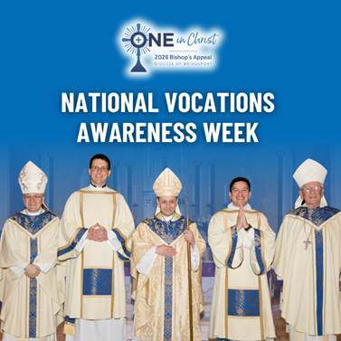
Caption Copy:
This week, we celebrate the courage of those listening for God’s call and the beauty of saying “Yes” to a life of service in the Church. Whether the Lord is calling someone to the priesthood, religious life, marriage, or dedicated single life, every vocation is a gift to the Body of Christ. ✝️💙
Through the 2026 Bishop’s Appeal, our Diocese continues to support the formation of future priests and leaders, offering the guidance, education, and spiritual direction needed to help them discern with confidence and hope. Your generosity truly shapes the future of our Church. 💒
As we begin this special week, please join us in praying for holy, joyful, and generous vocations. Lord, open hearts to Your call and lead Your people to their true purpose. 🌿 Support the vocations of our Diocese by visiting 2026BishopsAppeal.org.
#2026BishopsAppeal #DioceseofBridgeport #OneinChrist #VocationAwarenessWeek
NOVEMBER POSTS
POST #22 TOPIC: | Thanksgiving Reflection | RECOMMENDED POST DATE: | Monday, November 23
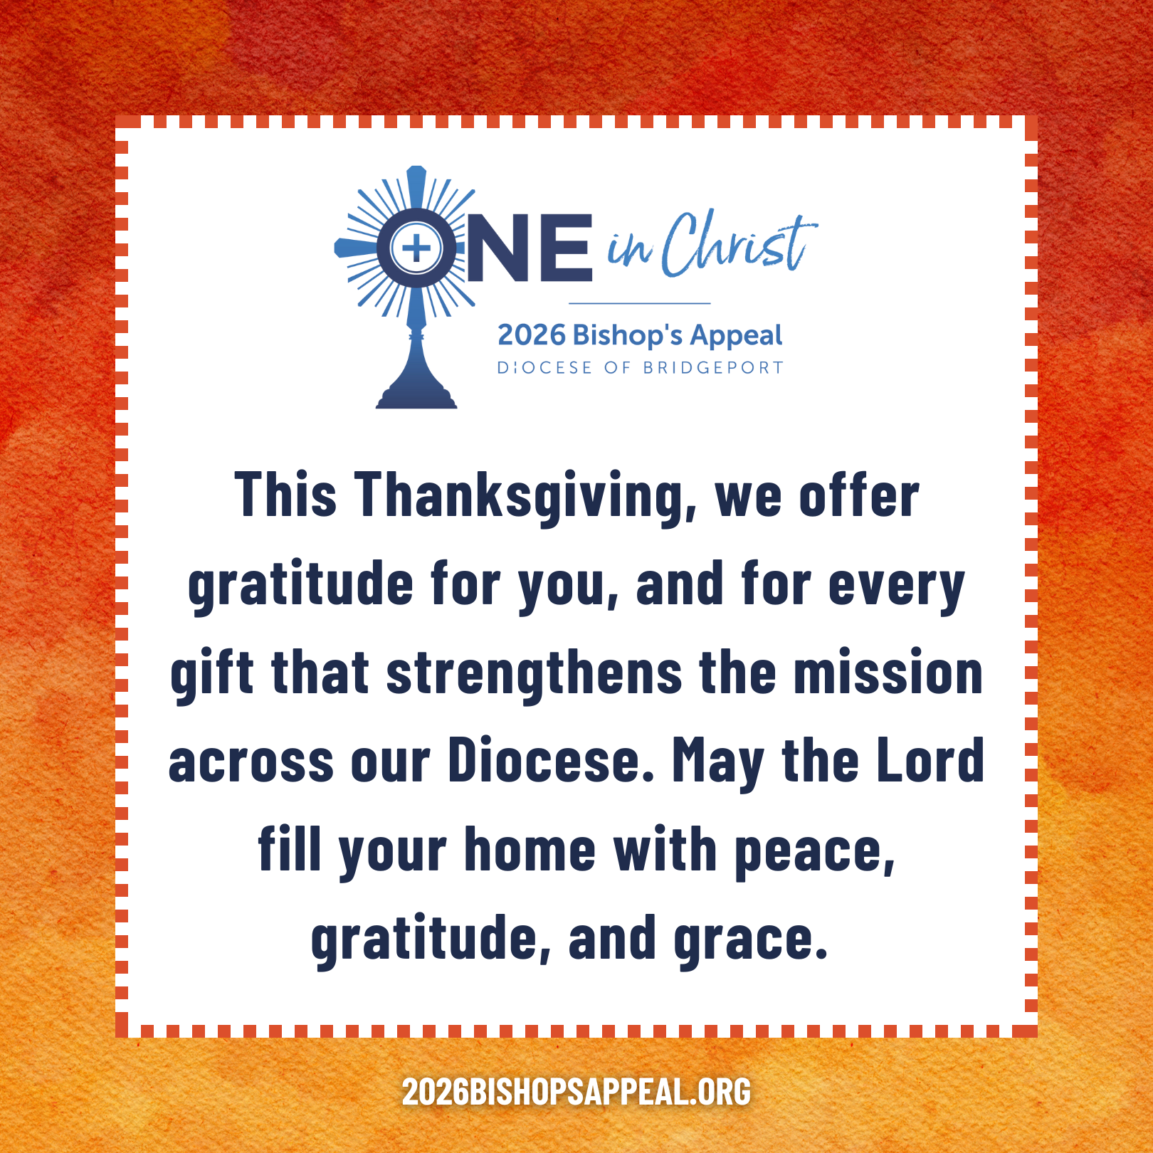
Caption Copy:
As we gather around our tables this Thanksgiving, we pause to remember that every blessing comes from the Lord, who calls us to walk with Him and with one another each day. ✝️💛
Through the 2026 Bishop’s Appeal, our diocesan family unites as One in Christ, supporting ministries that no parish could accomplish alone. Your generosity empowers our Church to:
• 🤝Help our neighbors in crisis through Catholic Charities
• 🙏 Form priests, deacons, and lay leaders
• 👧👦 Nurture children and adults in their growing faith
• 🌟 Support all our families
• 🤝 Bring Christ’s comfort to the grieving, isolated, and ill
• ❤️ And much more!
This Thanksgiving, we offer gratitude for you, and for every gift that strengthens the mission across our Diocese. May the Lord fill your home with peace, gratitude, and grace.
Thank you for walking with us as One in Christ. 🙏 Make your gift to the Bishop’s Appeal today! Visit: 2026BishopsAppeal.org
#2026BishopsAppeal #DioceseofBridgeport #OneinChrist #Thanksgiving
DECEMBER POSTS
POST #23 TOPIC: | Preparing for Christmas | RECOMMENDED POST DATE: | Friday, December 18
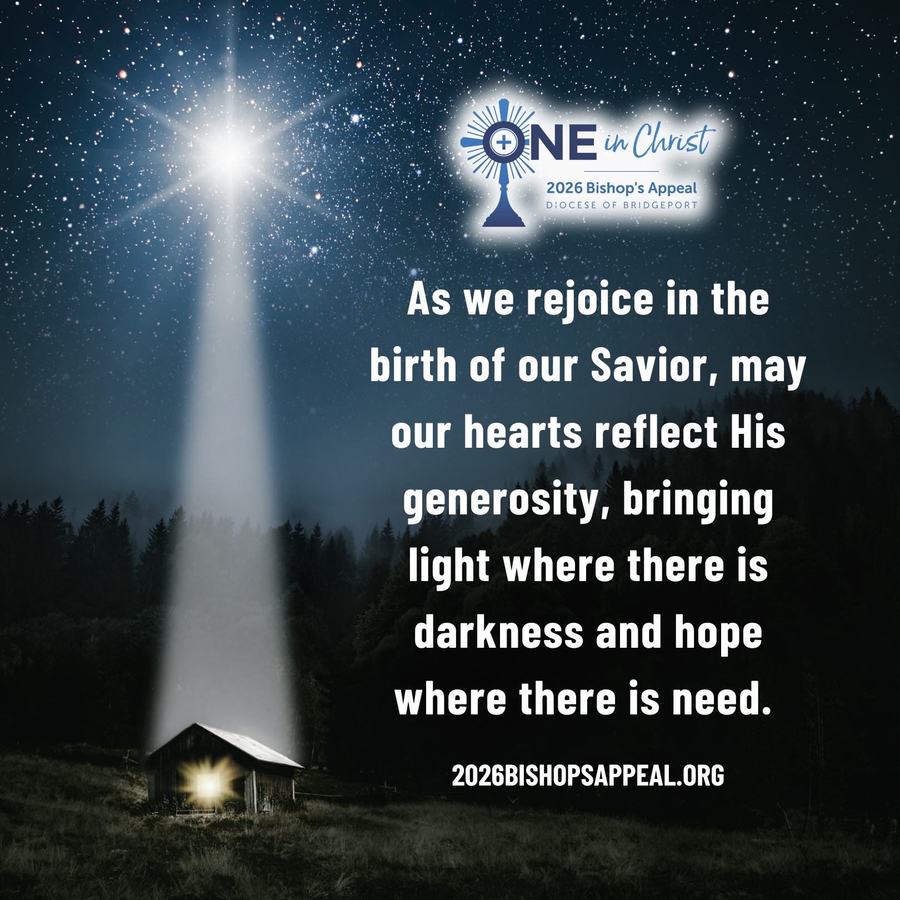
Caption Copy:
As we anticipate Christmas, we reflect on the miracle of the Word made flesh, the Light who enters our world to bring hope, healing, and salvation. ✝️🌟
Through the 2026 Bishop’s Appeal, we continue Christ’s mission by supporting ministries that share His love with those who need it most. Your generosity helps form future priests, strengthen families, lift up the poor, comfort the suffering, and open doors to Catholic education. 💒❤️
As we rejoice in the birth of our Savior, may our hearts reflect His generosity, bringing light where there is darkness and hope where there is need.
Thank you for supporting the Bishop’s Appeal and helping us walk together as One in Christ. To continue supporting, please visit 2026BishopsAppeal.org
#2026BishopsAppeal #DioceseofBridgeport #OneinChrist #Christmas

DECEMBER POSTS
POST #24 TOPIC: | End of Year Thank You | RECOMMENDED POST DATE: | Monday, December 28
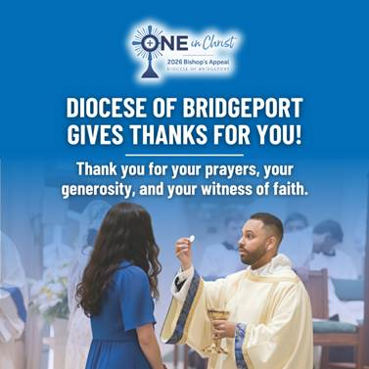
Caption Copy:
✨ As this year comes to a close, the Diocese of Bridgeport gives thanks for YOU. ✨
Because of your generosity to the Bishop’s Appeal, lives across our Diocese have been transformed:
- Neighbors in crisis receiving hope through Catholic Charities 🤝🌟
- Seminarians answering God’s call 🙏🔥
- Young adults finding faith-filled community ✨💒
- Deacons and lay leaders growing in service and formation 📖
- Families strengthened through youth ministry and accompaniment 💛👨‍👩‍👧‍👦
- Retired priests cared for with love and dignity ✝️❤️
Every story this year, every vocation, every ministry, every act of mercy was made possible because our diocesan community walks One in Christ.
🙏 Thank you for your prayers, your generosity, and your witness of faith.
Together, we continue to bring Christ’s love to every corner of Fairfield County. 💛
#2026BishopsAppeal #DioceseofBridgeport #OneinChrist #ThankYou

